

**QuickEase:** Streamlining Study Sessions with OpenAI Technology (GPT 4o)

*Caingles, Nathannael Andrew G.*

*Gevero, Clyde H.*

*Navares, Kenneth L.*

*Tagaan, Dan Joshua M.*

**A CAPSTONE PROJECT**

Bachelor of Science in Information Technology

Department of Information Technology

College of Information Technology and Computing

University of Science and Technology of Southern Philippines

Cagayan de Oro City, 9000, Philippines

December 2024

**APPROVAL SHEET**

**ABSTRACT**

In today’s academic environment, students often struggle to balance their study sessions due to non-academic responsibilities that demand significant time and energy. Additionally, tasks like manually summarizing study materials and creating self-assessment tools, such as flashcards and quizzes, consume a lot of time and effort, reducing the effectiveness of their study sessions. To address these challenges, the QuickEase web and mobile application was developed to streamline students’ study sessions. The system uses technologies such as OpenAI GPT-4o, Google Vision, and ConvertAPI which allows students to upload study materials in various formats and automatically generate summaries, flashcards, and quizzes. Additional features, including a Pomodoro Timer and a Gamified Badge System, help boost productivity, motivation, and engagement of the students using the system. The user testing showed an average System Usability Scale (SUS) score of 82.29, categorized as "Excellent," while ISO/IEC 25010 evaluations highlighted strong functional suitability and usability. These results conclude that QuickEase successfully addressed key challenges in streamlining students’ study sessions. The researchers recommend extending availability to iOS and introducing an AI chatbot for additional study assistance.

**Keywords:** *Streamlining Study Sessions, GPT-4o, Google Vision, Pomodoro, Badge System*

**DEDICATION**

This Capstone Project, QuickEase, is dedicated to the students who face the challenges of balancing academic and non-academic responsibilities. We hope this system serves as a practical tool to simplify their study sessions.

We extend this dedication to our families, friends, and loved ones, whose unwavering support and encouragement have been our foundation throughout this journey. Your belief in our potential has been a constant source of motivation, and we are deeply grateful for your presence in our lives.

To the esteemed professors and faculty members of the Information Technology Department – USTP CDO, we dedicate this work as a testament to the knowledge, guidance, and mentorship you have shared with us. Your dedication to teaching has shaped not only this project but also the future paths we will tread. It is our way of expressing gratitude for the impact you have made.

Lastly, this project is a reflection of our commitment as developers and as students of the University of Science and Technology of Southern Philippines. It embodies our passion for innovation and our dedication to excellence. We hope that this endeavor inspires others to explore the limitless possibilities of technology and continue striving for greatness.

**ACKNOWLEDGEMENT**

We, the QuickEase Developers, express our heartfelt gratitude to everyone who contributed to the successful completion of our Capstone Project.

First and foremost, we extend our deepest thanks to **Mr. Dario C. Miñoza**, our adviser, for his invaluable guidance, patience, and constructive feedback. His expertise has been instrumental in shaping the success of this project and helping us navigate challenges with confidence.

We sincerely thank our panelists, **Ms. Charlane B. Vallar, Mrs. Jc Vanny Mill Saledaien-Tong,** and **Mr. Jhon Harvey Babia**, for their patience and dedication in reviewing and correcting our manuscripts. Their insightful evaluations, thoughtful recommendations, and encouragement have greatly improved both the QuickEase system and our documentation.

We also acknowledge **DOST Region 10**, the Capstone Stipend Allowance provided significant support to one of our team members, Nathannael Andrew G. Caingles, a proud DOST scholar.

We are deeply grateful to the families of each team member. The **family of Nathannael Andrew Caingles**, the **family of Clyde Gevero**, the **family of Kenneth Navares**, and the **family of Dan Joshua Tagaan**, for their unwavering financial and emotional support. We especially thank the **Tagaan Family** for their thoughtful gesture of preparing meals for our panelists during the Proposal and Final Defense, adding warmth and hospitality to the atmosphere during the defense.

Special thanks go to **Emmanuelle James Duallo** and **Mohamad Bara-amal Dida-agun** for their assistance in creating the manuscript. Their willingness to share their papers provided us with invaluable thoughts, insights, and ideas that guided us throughout this process.

Also, to our seniors, we are grateful to **Gerarld Reponte Agbon**, **Mark Rywell Gemina Gaje,** and **Angel Rose Naval** for allowing us to view their Capstone Papers, which served as essential references. Additionally, we express our appreciation to **Ian Nico Caulin**, **Marry Joy Colis**, **Reshie Ky Ravidas**, and **Mark Gil Rusiana**, whose innovative use of OpenAI technology in their Capstone Project inspired ideas and provided direction for the QuickEase.

We extend our appreciation to the respondents who participated in the user testing, as their valuable feedback played a crucial role in refining and improving QuickEase. To our friends and classmates, your encouragement and support throughout this journey meant the world to us.

Finally, we offer our deepest thanks to the **Almighty God**, whose guidance, grace, and strength sustained us through this endeavor. This project stands as a testament to the collective efforts, support, and faith of everyone involved.

**TABLE OF CONTENTS**

**PAGE**

**TITLE PAGE i**

**APPROVAL SHEET ii**

**ABSTRACT iii**

**DEDICATION iv**

**ACKNOWLEDGEMENT v**

**TABLE OF CONTENTS vii**

**LIST OF FIGURES x**

**LIST OF TABLES xi**

**CHAPTER 1 1**

INTRODUCTION 1

1.1 Background of the Study 1

1.2 Statement of the Problem 5

1.3 Objectives of the Study 6

1.4 Conceptual Framework 7

1.5 Significance of the Study 7

1.6 Scope and Limitations 8

**CHAPTER 2 9**

REVIEW OF RELATED LITERATURE 9

2.1 Introduction to the Problem: Student’s Challenges on Study Sessions 9

2.2 Extraction Methods of Summarization and Auto-Summarization Approaches 10

2.3 Self-Assessment Approaches: Flashcard Methods and Quiz Methods 11

2.4 Prompt Engineering Tactics 12

2.5 Structuring an Effective Summary, Flashcards, and a Multiple-Choice Quiz 13

2.6 Pomodoro Time-Management and Gamification Approaches 14

2.7 Synthesis 15

**CHAPTER 3 17**

METHODOLOGY 17

3.1 Data Gathering 18

3.2 User Design 19

3.2.1 Prototype 19

3.2.2 Test 19

3.2.3 Refine 19

3.3 System Design 20

3.3.1 System Architecture 20

3.3.2 Use Case Diagram 22

3.3.3 Context Diagram 24

3.3.4 Level-1 Data Flow Diagram 26

3.3.5 Level-2 Data Flow Diagram 28

3.3.6 Entity Relationship Diagram 30

3.4 Development and Implementation 32

3.4.1 Hardware Requirements 32

3.4.2 Software Requirements 32

3.4.3 Technologies Used 34

3.5 Testing and Evaluation of the System 39

3.5.1 Pilot Testing 39

3.5.2 System Functionality Testing 40

3.5.3 System Evaluation Standards 47

3.6 System Deployment 49

**CHAPTER 4 50**

RESULTS AND DISCUSSION 50

4.1 Generating Summaries 50

4.2 Generating Flashcards 51

4.3 Generating Quizzes 53

4.4 Pomodoro and Badge System 54

4.5 System Evaluation 56

4.5.1 System Usability Scale 56

4.5.2 ISO 25010 60

4.5.3 Functionality Testing 66

**CHAPTER 5 72**

CONCLUSIONS AND RECOMMENDATIONS 72

5.1 Conclusion 72

5.2 Recommendation 73

**BIBLIOGRAPHY 74**

**APPENDICES 78**

APPENDIX A: Digital Solution Showcase 78

APPENDIX B: User Manual 79

APPENDIX C: Code Snippets 80

APPENDIX D: Timeline of Tasks 85

APPENDIX E: System Evaluation Questionnaires 86

APPENDIX F: System Evaluation Survey Documentation 90

APPENDIX G: Meeting Consultations 91

APPENDIX H: Curriculum Vitae 92

# **LIST OF FIGURES**

**TABLE PAGE**

1 | Conceptual Framework 6

2 | Google Cloud Vision Architecture 11

3 | Agile Methodology 17

4 | QuickEase’s System Architecture Diagram 21

5 | QuickEase Use-Case Diagram 23

6 | QuickEase Context Diagram 25

7 | QuickEase Level 1 Data Flow Diagram 27

8 | QuickEase Level 2 Data Flow Diagram (Process 2) 29

9 | QuickEase Entity Relationship Diagram 31

10 | Likert Scale 47

11 | Generating Summaries User Interfaces 51

12 | Generating Flashcards User Interfaces 52

13 | Generating Quizzes User Interfaces 54

14 | Pomodoro Timer and Badge System 60

15 | SUS Scores Interpretation 60

16 | ISO Product Quality 60

# **LIST OF TABLES**

**TABLE PAGE**

1 | Features Comparison with the Existent Applications/Technology 16

2 | Hardware Specification Requirements 32

3 | Software Specification Requirements 38

4 | QuickEase Functionality Testing 40

5 | Likert Scale 56

6 | SUS Questionnaire 56

7 | SUS Responses and Computed Scores 58

8 | SUS Interpretation Score 60

9 | Functional Suitability Mean Result 61

10 | Performance Efficiency Mean Result 62

11 | Usability Mean Result 63

12 | Reliability Mean Result 64

13 | Security Mean Result 65

14 | Overall Mean Result 66

15 | Functionality Test for Users (Results) 68

**CHAPTER I**

**INTRODUCTION**

**1.1 BACKGROUND OF THE STUDY**

In today's fast and technology-driven academic environment, college students often struggle to balance their study sessions productively due to the demands of non-academic responsibilities. This assertion was supported by survey research conducted at the University of Lima, Peru, by **Lolandes et al. (2020)** which observed that students with numerous non-academic responsibilities report lower productivity and poorer time management in their academic studies. According to a study conducted at Bohol University **Trabajo (2020)**, students require a significant amount of time for studying since their routines involve reading educational materials, summarizing and organizing those materials, and preparing for tests by reviewing or self-assessing. However, this creates a conflict for students who already have limited time due to their non-academic responsibilities. The conventional approach to studying involves manually creating digital or handwritten summaries, and self-assessment materials such as electronic or physical flashcards, and self-made questions. These methods, while effective to some content, are time-consuming which is counterproductive as far as their time management in studying is concerned. In addition, **Trabajo (2020)** alsostated that the manual nature of these processes can be tedious which usually leads into unproductive study sessions.

Given these challenges, automated summarization is considered as a viable solution. **Sharma & Sharma (2023)** highlighted that automatic summaries save time compared to human summarizers, who need considerable time to manually create summaries. It is also stated that automatic summaries are less biased because they do not rely on personal interpretations. This lack of bias can also be beneficial for systems that will implement to use the summary data into a question-answer feature as it ensures more objective and consistent knowledge representation compared to human summaries.

Throughout the years, there have been established technologies that enable Automatic Text Summarization. These particular features that automates Text Summarization as stated by **Liu, Yuyang & Song (2023)** are the Optical Character Recognition (OCR) and the Natural Language Processing (NLP). The OCR technology reads and converts various types of documents such as text files, Portable Document Format (PDF)s, or images into a machine-readable text. The processed machine-readable text will then be processed by any NLP technology as it enables computers to understand, interpret, and generate human language. These particular capabilities are crucial for generating relevant summaries.

To address the problem of time-consuming manual summarization, researchers will integrate OpenAI (Artificial Intelligence) Technology, particularly the Generative Pre-Trained Transformer (GPT) 4o Model which is acknowledged by **OpenAI (2024)** as an advanced and reliable model in terms of language understanding and generation. Furthermore, the researchers will also implement the OCR capabilities of ConvertAPI and Google Vision that allows the researchers to request file and document conversions, and image transcriptions. With these technologies, the system will have a diverse transcription of study materials, which can then be summarized by GPT-4o. By automating these processes, the researchers will be able to automate the summarization of students’ study materials such as scanned documents, digital documents, PDFs, an image of a study material (e.g., photos of handwritten notes or book pages) more quickly, and less bias.

Moreover, students not only consider summarizing their topics as time consuming but also the process of creating self-assessment study materials. These type of study materials are crucial as it allows them to practice and review their knowledge on what they’ve read and learn, yet most of the time their motivation and engagement to it diminishes as the process of manually creating these materials are too tedious. The common self-assessment materials that student nowadays used today include flashcards and self-made or pre-made quizzes. According to the research study published on the University of Santo Tomas Manila, Philippines by **Herrera Caldes et al. (2020)** claims that flashcards are an effective study method to review students’ knowledge, as they help students memorize key terms and definitions quickly. Another methodology which is the question and answer were also considered as a good way to test their capacity of their knowledge learned. In the study of **Turhan Kariko & Ayuningtyas (2021)** on examining students’ preferences self-assessments, it was concluded on their survey that students find test-type assessments a good way to have a self-reflection of their current knowledge on a certain topic. It was also observed that most of their preferences favored a multiple-choice type of test since this simple yet effective test stimulates the students’ active and self-managed learning by letting them exposed on a variety of choices making their knowledge retrieval more accessible.

In order to provide a solution for time-consuming and tedious process of creating self-assessment materials, the researchers plan to utilize the advance capabilities of GPT 4o Model. By leveraging prompt engineering, researchers can generate specific outputs such as flashcard contents and test questions based on students’ summary outputs. This specific data extraction will then be used to provide the students an automated set of flashcards, and a test based on a respective summary, making the process significantly less tedious compared to manual creation.

As explained by the researchers on integrating the OpenAI Technology, Prompt Engineering was mentioned beforehand. Prompt engineering involves crafting precise inputs to guide the AI in producing desired outputs. **Ramprasad et al. (2023)** emphasize that using attribute-specific parameters in prompts can improve the reliability and desired outcomes of AI models. According to OpenAI's Prompt Engineering guidelines **(OpenAI, 2024),** tactics such as using delimiters to indicate distinct parts of the input and instructing the model to reference the exemplar is encouraged to be implemented to achieve a better and desired outputs. The delimiters tactic will be used to extract specific data formats needed for the summary note contents, flashcards, and quizzes, while the exemplar tactic will involve using student’s summary note contents to create relevant summaries. These automated summaries will then serve as references for generating flashcard and quiz contents.

Although not proven, there’s still a possible that the students despite being able to have an automated summarization and an automated self-assessment study material, they still often find themselves distracted especially in the digital world. As stated on the exploratory descriptive study by **Mrazek et al. (2021)**, the research findings suggested that students nowadays, are distracted 38% of the time when they’re studying. Having this amount of time to be distracted will result into a less productive and poor time management of study sessions. On the 135 students surveyed, 64% believed that they should focus more on studying and are willing to silence, or not use their phones.

However, completely avoiding digital devices is nearly impractical since most study resources are now digital. Hence, a proposed solution by **Shen & Andaya (2024)** in their application, where it uses the Pomodoro Technique and a Gamification Element to enhance student’s productivity. The Pomodoro Technique is a time management that break work into a iterate cycle of working 25 minutes in length, followed by 5 minutes of short-break or 15 minutes of long-breaks to rest and recharge. The method is designed to improve productivity and time-management by encouraging people to strictly follow the designed cycle. On the other hand, gamification uses the elements we often see in games to motivate users such as point scoring, competition, and rewards leading to a better engagement and productivity. In the case of **Shen & Andaya (2024),** they integrated a pomodoro timer within their application and a chicken character that expresses emotion based on the typing speed of the user. For this reason, the researchers also plan to implement a similar approach of Pomodoro Timer which can be optionally disable according to student’s preferences, and a gamification element which is a badge system that will reward students based on a respective achievement (ex: Getting a perfect score on a test) in hopes of further improving the student’s time-management, and productivity.

All things discussed and considered, this study addresses the problem of students' difficulty in managing their study sessions due to non-academic responsibilities, and time-consuming and tedious manual study methods. By integrating an advanced and emerging technology specifically GPT-4o which is currently one of the best A.I Models, the research aims to streamline the creation of summaries and self-assessment materials, thus enhancing study sessions. Additionally, the implementation of the Pomodoro Management and gamification elements seeks to reduce distractions and boost motivation thus improving time-management and productivity. Leveraging these technological advancements can significantly improve students' study habits during study sessions.

**1.2 STATEMENT OF THE PROBLEM**

1. **Time-Consuming and Biased Summarization:** Manually summarizing learning materials such as portable document format (PDF) files, modules, topics and lessons from textbooks whether digitally created or handwritten is a time-consuming task. This process just takes so much time and can hinder student’s ability to quickly get essential information and keep up with their study schedules, especially to those students who have less time to study due to numerous non-academic responsibilities. Additionally, summarization made by humans tends to become biased since it relies on personal interpretations, leading to some contents not being included due to poor understanding.
2. **Tedious Study Materials Creation**: Creating study materials and self-assessment materials manually like flashcards and practice quizzes/tests can be exhausting for it requires a lot of time and effort. Given that students have limited time, it is time-consuming and is counterproductive as far as time management in studying is concerned. This tedious process also diminishes student’s motivation to actively engage in self-assessment or study practices which are necessary to know if they make progress.
3. **Time Management and Productivity Challenges:** Students continue to face significant obstacles in effectively managing their time during study sessions. Unavoidable distractions, such as phone calls, text messages, and notifications from other applications, often lead to a loss of attention. These interruptions, coupled with a lack of interactivity in learning materials, can make study sessions feel unproductive and diminish students' motivation, negatively impacting their overall study sessions.

**1.3 OBJECTIVES OF THE STUDY**

This study aims to address the challenges students face in managing study sessions by developing a web and mobile application designed to streamline learning processes and enhance productivity. The system leverages advanced technologies to automate the creation of study materials, promote effective time management, and improve students' motivation through gamification. Specifically, it aims:

1. To design and develop a system that allows students to upload study materials in various formats (e.g., text, PDFs, and images) and automatically generate summaries, flashcards, and quizzes.
2. To integrate a Pomodoro Timer and a Gamified Badge System to further enhance time management, productivity, and student’s motivation.
3. To evaluate the system’s effectiveness in streamlining study sessions through user testing, using the System Usability Scale (SUS) and ISO/IEC 25010 standards to assess usability, functionality, and overall quality.
4. To deploy the web application on Vercel, the backend on Digital Ocean, and an Android Package Kit (APK) for mobiles devices, ensuring students can access the system via both web and mobile platforms.

**1.4 CONCEPTUAL FRAMEWORK**

The ***Figure 1*** outlines the overall structure and the researchers’ process of the capstone project. This framework illustrates the flow of the study from the identification of student challenges to the development, evaluation, and deployment of the QuickEase Web Application.

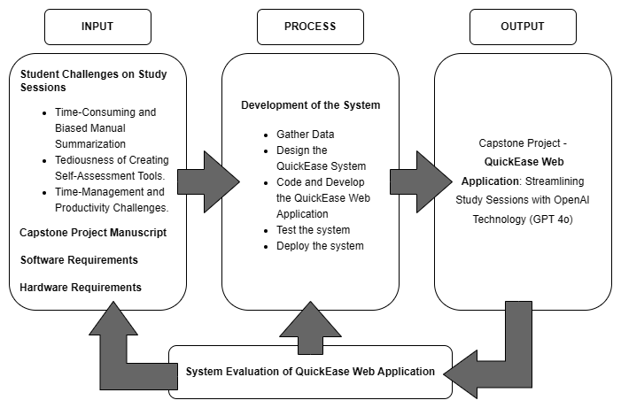

***Figure 1 | Conceptual Framework***

**1.5 SIGNIFICANCE OF THE STUDY**

The proposed system offers significant benefits to college students by providing an alternative way of summarizing and creating study materials based on the given learning materials, particularly to those students who have less time to study. By utilizing AI-powered summarization tools and self-assessment study material generation features, students can streamline their study sessions and enhance their overall learning experience. It promotes learning interactivity by having an auto-generated study materials such as flashcards and practice test/quiz as their self-assessment tool in order for them to self-evaluate their learning progress. Additionally, by providing students with techniques and tools such as Pomodoro Technique to manage their time for study sessions and Gamification elements to increase motivation and engagement, it can contribute to improve their productivity and may lead to a better academic performance. With these, it increases student’s motivation to delve into their study sessions.

**1.6 SCOPE AND LIMITATIONS**

The researchers will focus on developing a system that will help users (students) to simplify the conventional process of summarization into automated summarization which will give the students an alternative way to extract key information on learning materials, and it also offers an option to form it as flashcards and multiple-choice practice quiz serving as their self-assessment tool. Additionally, users can study with the generated summary notes and flashcards with an optional pomodoro timer to be used if they want to time and be strict to themselves while studying.

The Open AI technology has its own limitations that may affect the overall performance of the system. A good model has a seventy to ninety percent accuracy rate since all AI models are not perfect. Given the circumstances, it may be prone to some inaccurate response of desired outputs. In the context of our system to these limitations, when handling images with text of non-latin alphabets such as Korean and Japanese, the model may not optimally perform, the model may also struggle in understanding graphs or text if these were styled like solid, dashed, or dotted and when it comes to accuracy, the model may sometimes not have a stable accuracy **(OpenAI, 2024).** Still, there’s no AI model that has 100% accuracy yet the researchers ensured that the model that will be used in this study which is particularly GPT 4o is considered one of most advanced models that Open AI technology has.

This study may improve student’s academic performance or the academic ability but since there are external factors that could affect the desired outcome such as student’s motivation, engagement, and dedication to studying, the researchers cannot guarantee that it will make them reach their full potential because it also depends on each student’s situation and how committed they are to utilize the tools and strategies provided. Furthermore, while the system complements conventional study methods, it does not aim to replace them entirely. The system's effectiveness may vary depending on individual learning styles and preferences, as well as the specific nature of learning materials.

**CHAPTER II**

**REVIEW OF RELATED LITERATURES**

This chapter explores the relevant literature and studies that provide a solid foundation for this research, elucidating the rationale behind the study. This section also delves and explores how the integration of advanced solutions such as Automated Summarization and Auto-Generation of Self-Assessment Materials, and productivity tools and techniques specifically Pomodoro Timer, and Gamification Elements can potentially alleviate the problems of the study.

**2.1 Introduction to the Problem: Student’s Challenges on Study Sessions**

In the study of **(Gallardo-Lolandes et al., 2020)** about Time Management and Academic Stress in Lima University Students, it shows that there was a correlation between student’s stressors and their time management in studying their academics. The study mentions that students' non-academic responsibilities, such as part-time jobs, family duties, and social commitments are considered as stressors. Students burdened with numerous responsibilities reported to have less time on studying their academics.

Additionally, there’s also a study about the Study-Habits of First Year College Students of the University of Bohol. According to insights of **(Trabajo, 2020),** the students' study routine typically involves reading materials, summarizing these materials, creating self-assessment study materials and test preparation. These findings also indicate that the students spend a lot of time into reading and summarizing their study materials other than test preparation which they should be focusing more on when it comes to upcoming quizzes and exams. Moreover, the said combination of student’s external or non-academic responsibilities and time-consuming study habits creates a paradox and a challenging environment for students, making it more difficult for them to manage and streamline their study sessions effectively. The student’s need to balance academic and non-academic tasks often leads to students having not enough time to their typical routine of studying which potentially results to much more unproductive study sessions.

**2.2 Extraction Methods of Summarization and Auto-Summarization Approaches**

Text Summarization is the process of transforming a long text into a shorter version, creating a thorough and meaningful summary. According to the study of **(Chintan A. Shah & Prof. Neelam Phadnis, 2022)** there are two techniques of extracting data from the referenced text. These techniques are called Extractive Summarization and Abstractive Summarization. The Extractive Summarization extracts relevant phrases and combining these phrases together to form a single and cohesive summary. On the other hand, Abstractive Summarization develops a shorter text that may not be present on the referenced text, developing new words to shorten the phrases yet maintaining its core meaning and concepts. Moreover, in the comprehensive review about text summarization techniques by **Sharma, G., & Sharma, D. (2023)** stated that the Extractive and Abstractive Summarization have its own pros and cons. The extractive summarization is much easier to implement since it computationally less demanding, and maintains a factual accuracy of the referenced text but the downside of the technique is that it lacks coherence, meaning it’s plainly copied and pasted yet in a shorter version. On the contrary, Abstractive Summarization creates summaries with new words and phrasing to match the coherence of the current text, making it much more readable, and understandable, still this technique requires much more complex and advance natural language processing, and has higher chance to present new information out of the referenced text.

Conventionally, the Natural Language Processing (NLP) and the Optical Character Recognition (OCR) had been utilized for Auto-Summarization projects. As explained by **Liu, Yuyang & Song (2023),** the NLP fill the blanks of making an Auto-Summarization much human like and provide a better abstract of the information to be summarized. Furthermore, the OCR technology is also usually incorporated to Auto-Summarization projects to have more diverse scenarios such as generating a summary with an image text, making the Auto-Summarization much better, faster, and more versatile.

Consequently, there’s a study and a system made by **Jhansy Archana V., Vahini, M.S.S (2023)** at International Research Journal of Modernization in Engineering Technology and Science, an Auto-Summarization using NLP was developed. The developed project intends to use extractive and abstractive text summarization techniques to produce concise and coherent accounts of relevant information of the generated summary from the referenced texts. The project also used several NLP modules in Python such as Natural Language Toolkit (NLTK) and spaCy in conjunction with supervised and unsupervised machine learning algorithms, basically developing and training their own model. The results of the project concluded that the hybrid automatic text summarization which uses both Extractive and Abstractive text summarization techniques provides a robust summarization solution with higher accuracy and relevance compared to models that just uses one extraction technique.

In addition, there’s a study comparing Google Vision and Tesseract API conducted by **Kusmanto et al. (2024)** at Sebelas Maret University, Indonesia. The study concludes that the Google Vision’s Optical Character Recognition (OCR) algorithm is superior to Tesseract on the level of accuracy, sensitivity, and precision. In addition, the system architecture of Google Vision in ***Figure 2*** has also a Translation API, which the cloud runs only if the target language doesn’t match the source language.

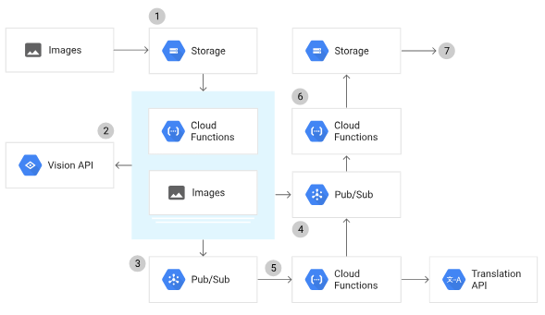

***Figure 2 | Google Cloud Vision Architecture***

**2.3 Self-Assessment Approaches: Flashcard Methods and Quiz Methods**

In the study conducted published on the University of Santo Tomas Manila, Philippines by **(Herrera Caldas et al., 2020)** Effective vocabulary acquisition strategies employed by Ecuadorian teachers and students: A cooperative experience using a flashcard web application claimed that flashcards, which is a set paired associate learning tasks for users, allows the memorization of large number of words over a short period of time. This method of study has really proven to be of help to students who really don't have too much time to study their academics due to other non-academic responsibilities. This study method allows them to quickly learn important information without wasting lots of time due to seeing only one side of a card reinstating an active recall of what is on the other side of the card.

For this reason, the study of **(Hartman et al., 2024)** about Creation of the First Alliance of Medical Student Educators in Radiology (AMSER) Sponsored Digital Flashcard Deck and a Review of Digital Flashcard Use among Medical Students has been developed. The study justifies that flashcards are a popular study method especially among medical students. This preference is largely attributed to the nature of medical education, which involves the extensive memorization of key terms and definitions. The study’s finding indicated that around 87.6% of medical students have used digital flashcards during medical school, which backs up the statement of the flashcard study material to be effective in key-terms and definition studying.

According to the study of **Turhan Kariko, A. A., & Ayuningtyas, P. (2021)** examined and concluded that student nowadays especially the characteristics of Generation Z, prefers online or digital multiple-choice type of quiz. One of the web-applications that nowadays used that offers this type of feature are the Kahoot and the Quizizz. These web-applications offers a dynamic multiple test variation, but the multiple-choice test is the popular type of test since it is simple yet effective to stimulate the students’ active and self-managed learning by letting them exposed on a variety of choices making their knowledge retrieval more accessible. The Kahoot and Quizziz aside from their test feature, these applications also utilize the gamification elements mainly the ranking system to keep the students more engage and motivated with the test materials. The Quizizz also utilizes their own AI model to generate a test based on users uploads such as documents, and PDFs. On the other hand, the Kahoot don’t have automated system since creating a test still involves manual inputs from the user.

**2.4 Prompt Engineering Tactics**

While numerous studies have been proposed to explain how Artificial Intelligence could help automate a task, a question about its reliability can also be considered. According to the study of **(Ramprasad et al., 2023)** Generating more consistent Subjective, Objective, Assessment, and Plan (SOAP) notes using attribute-specific parameters, the reliability and wanted results can be improved depending on the model’s specific prompts. In this work, the researchers assess the performance of large language models Generative Pre-Trained Transformer (GPT-3.5) for SOAP notes generation and compare them with fine-tuned models using automated metrics. The study proposed a solution to improve the consistency of the AI outputs by incorporating attribute-specific information via SOAP section information. To achieve this, the researchers integrate an extra layer of unique section-specific cross-attention parameters to existing encoder-decoder architectures. The said approach was then evaluated using a comprehensive suite of automated metrics and expert human evaluators, demonstrating that it leads to more accurate, and relevant information. The study also concluded that the model GPT 3.5 default prompts only have a fair performance compared to their own model, Bidirectional and Auto-Regressive Transformer (BART), in the wanted results of generating SOAP notes which a human would produce. This study demonstrates that the OpenAI GPT 3.5 model is better with a specific parameter prompts rather than a default prompts. To further back up the statement of the previous study, a study conducted by **(Levy et al., 2021)** Assessing the Impact of Automated Suggestions on Decision Making supports the conception that AI utilization requires a deep understanding of when and how to use specific model parameters. Misunderstanding these aspects can lead to suboptimal results and misplaced trust in the automation process.

Continuing the discussion regarding AI potential in automation and the fact that it greatly depends on particular parameters for its optimized results, means that a system using an OpenAI Technology should utilize the best tactics on Prompt Engineering. These tactics include delimiters, provide examples, specific length of the output, and reference text **(OpenAI, 2024).** Delimiters such as section titles, and quotation marks, can help to specify sections of text to be treated differently like where the title and contents of the summary should be placed. Providing examples and reference texts can also help the AI model to output a relevant and better data by providing a demonstration of the arrangement of the task. Lastly, specifying length of the outputs can also be utilize to have lesser token consumption of the OpenAI model.

**2.5 Structuring an Effective Summary, Flashcards, and a Multiple-Choice Quiz**

The process of creating a well-structured summary involves condensing the text, retaining the core ideas, and key points of the referenced text. According to **McCombes (2023)**, summarizing should have key points, and the core ideas should be organized into sections. These sections should also leave out irrelevant details so that the summary would remain focused and effective enough. It is also stated that the Introduction and the Conclusion sections of a summary play a significant role of being an effective summary. The introduction should set the stage by briefly stating the main context of the referenced content, on the other hand, the conclusion should wrap up the summary by reinforcing key points and by providing a sense of closure. These sections ensures that the summary content will have clarity and coherence. Speaking of clarity and coherence, **Nicholas (2023)** emphasized that a summary should be concise and objective, and also the structure should have clarity and coherence. Conciseness is the core of summarizing, rather than simply shortening the summary, it also should eliminate repetitive details while maintaining the integrity of the referenced text. Effective summaries are also objective, the content should not contain personal interpretation or bias as this will help remain the reliability of the content. Lastly, the summary contents should have clarity and coherence, these attributes help the summary to be understood easily because of the connecting ideas and logical flows.

As stated by **Asrani (2023),** flashcard contents should not be complex. Asrani recommend it to Keep It Simple Stupid (KISS) since simple, small, and direct questions are easier to recall and answers. Creating a lot of flashcards with smaller points are rather much effective than creating fewer flashcards with many points as this will make the reviewer remember much faster and easier which is important in a space repetition method of studying. Furthermore, the study of **Shin et al. (2019**) concludes that distractors that are effective are crucial elements of a well-designed multiple-choice quizzes. The purpose of the distractor is to challenge the quiz-taker by presenting possible or reasonable answers alternative to the correct one. The distractors should also be realistic and relevant to the question presented, and avoid ridiculous options. Incorporating misconceptions are also part of having an effective format of the distractor. Lastly, the distractors should have similar length and structure to the correct answer as this will avoid giving hints or revealing obviousness to the correct answer.

**2.6 Pomodoro Time-Management and Gamification Approaches**

**Caliso et al, (2022**) introduced the Pomodoro Management technique within their digital portal system. The Pomodoro Technique is a time management method developed by Francesco Cirillo that break work into a cycle of traditionally 25 minutes in length, followed by 5 minutes of short-break or 15 minutes of long-breaks to rest and recharge. The method is designed to improve productivity and time-management by encouraging people to strictly follow the designed cycle. In the case of Caliso, he integrated a Pomodoro Timer into the Mindanao International College Portal System to help with student time management. The timer allows students to work for 25-minute intervals and then take a 5-minute break. Afterward, the survey stated that the pomodoro time management has resulted in better productivity, as the structured work and break periods help students reduce the impact of distractions. The system was also proven to help people who struggle with not being able to be productive or get things started.

In relevance with the Pomodoro Management, another study by **(Santiago & Gurat, 2023)** about The Effect of Pomodoro Technique on Student Mendelian Genetics Concept Mastery during Synchronous Remote Learning also concluded that the Pomodoro technique is an effective strategy in increasing education productivity. The result of the study shows that students who have used or implemented the Pomodoro Technique has higher education productivity than the students who don't use the Pomodoro Technique.

Hence, the system of **Shen, S., & Andaya, M. (2024)** aside from the Pomodoro Time Management also integrated a gamify approach that keeps their users engaged, and motivated to interact with the system. Their system implemented a chicken character that interacts with the user based on their productivity, which in this case is the speed type of the users to keep them writing an essay.

**2.7 Synthesis**

The ***Table 1*** provides a comparative analysis of QuickEase Web Application and existing systems, such as IRHETS, AMSER Digital, Quizziz, Kahoot, AIRCC, and MIC Portal. QuickEase stands out by integrating all features of the existing systems like Auto-Summarization, Flashcard and Test Generation tailored from summarized content, Gamification elements, and a Pomodoro Timer. These combined functionalities offer a comprehensive, streamlined platform for enhancing study sessions.

***Table 1 | Features Comparison with the Existent Applications/Technology***

|  |  |  |  |  |  |  |
| --- | --- | --- | --- | --- | --- | --- |
| **Features** | **Proposed System** | **Existing Systems** | | | | |
| QuickEase Web-Appliaction | IRHETS | AMSER Digital | Quizizz & Kahoot | AIRCC | MIC Portal |
| Auto-Summarization | Checkmark with solid fill | Checkmark with solid fill |  |  |  |  |
| Flashcard-Generation | Checkmark with solid fill |  | Checkmark with solid fill | Checkmark with solid fill |  |  |
| Test-Generation | Checkmark with solid fill |  |  | Checkmark with solid fill |  |  |
| Gamification | Checkmark with solid fill |  |  | Checkmark with solid fill | Checkmark with solid fill |  |
| Pomodoro-Timer | Checkmark with solid fill |  |  |  | Checkmark with solid fill | Checkmark with solid fill |

**CHAPTER III**

**METHODOLOGY**

This chapter will explain how the researchers conducted the study and developed the project using the Agile Methodology. Researchers have gathered information from research online articles, relevant literature and studies, and survey questionnaires to obtain insights and views from students about the conducted research. Furthermore, the researchers came up with the system's design how it operates, the data flow, the entity relationship diagram, its system's architecture, software, and hardware to be used. After planning the design, researchers moved on to the development and implementation of the system. The researchers test it once built to ensure it will work properly as intended and the system is put to use if the testing goes well.

The researchers used the Agile Methodology to develop the system due to its iterative and flexible approach. This ensures the system remains user-centric and addresses users' needs (students). The agile method focuses on collaboration and incremental progress which facilitates a seamless integration of features like automated summarization, self-assessment tools, and productivity enhancements.

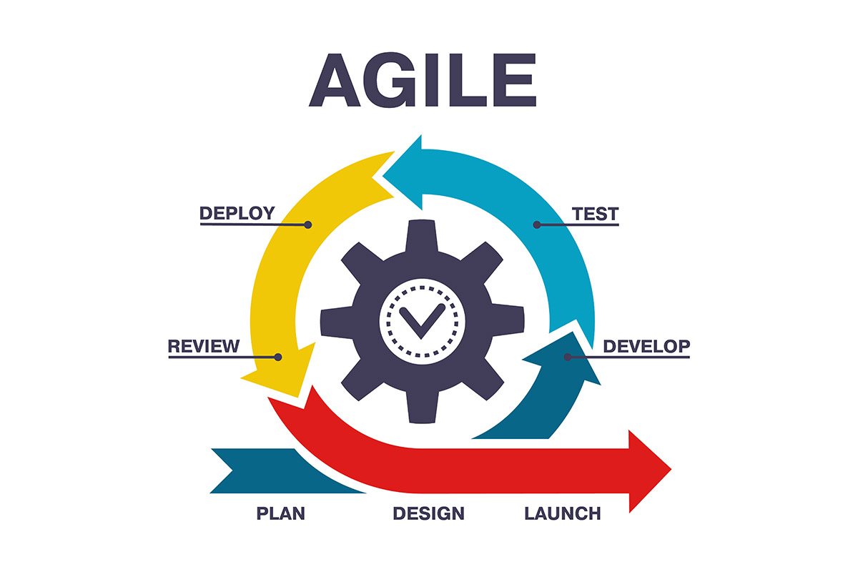

***Figure 3 | Agile Methodology***

**3.1 DATA GATHERING**

This study was carried out at the University of Science and Technology of Southern Philippines. The primary participants in this research are students from various departments and academic years. The researchers conducted a Google Forms survey to collect data from these students. The survey received responses from a total of 40 participants.

The survey results revealed significant insights into the student's study habits and preferences. One of the key findings was that 90% of the respondents found manual summarization of study materials to be time-consuming. This indicates a substantial portion of students facing challenges with the conventional method of summarization. Additionally, the data showed that 92.3% of the students found an automated summarization tool to be beneficial. When asked about the time-consuming nature of making flashcards and other study aids, 65% of the respondents agreed that these tasks were tedious and tiring. Correspondingly, 95% of the students found an automated tool for creating flashcards based on their study materials to be beneficial, indicating a clear demand for such a tool. The survey also explored the students' views on creating self-assessment tools, such as self-tests and questionnaires. The results showed that 60% agreed that this task is too time-consuming and tedious. Furthermore, 94.9% of the respondents found an automated tool for creating self-assessment quizzes to be very beneficial.

Distractions due to digital devices during study sessions were also a concern, with 87.5% of the students reporting that they always get distracted. To address this, 82.5% of the students expressed a willingness to use the Pomodoro Technique to reduce distractions and improve productivity.

The likelihood of using an application that integrates all study tools, including summarization, flashcards, quizzes, and time management, was high indicating 100% of the respondents were very likely to use such an application, indicating strong support for a comprehensive study tool. Moreover, 100% also of the respondents believed that using an integrated study tool would be very beneficial in improving time management and productivity. This underscores the potential impact of a holistic study aid on students' academic performance.

These findings underscore the necessity for automated study tools to improve time management and productivity in students' study sessions.

**3.2 USER DESIGN**

In this phase of the project, the researchers designed prototypes focusing on the key features such as Summary Notes Generation, Flashcard Generation, Quiz Generation, Pomodoro Timer, and a Badge System. Using Figma, the prototypes served as interactive visual mockups, enabling students from CITC and CSTE to explore the system and provide feedback. The feedback gathered through comments, and observation highlighted the problems in the area of User Interface and User Experience of the students.

**3.2.1 Prototype**

The prototypes created in this phase visually simulated the functionalities of QuickEase, offering users an interactive experience of its key features. Although not fully functional, these mockups allowed students to visualize the system's design and basic operations, ensuring the interface layout and navigation paths were clear and engaging.

**3.2.2 Test**

Students tested the prototypes by navigating through the system and providing feedbacks. Observations revealed several issues concerning the lack of back buttons, confusing interface elements, and distracting colors. This feedback underscored the need for improvements to make the system more natural and user-friendly.

**3.2.3 Refine**

The researchers refined the system based on user feedback, addressing navigation challenges by adding back buttons and enhancing button recognizability. To reduce distractions and improve focus, a monochromatic color scheme was implemented on the Development Phase, supported by Sandu (2024), who noted that monochromatic color scheme enhances focus by minimizing visual clutter and improving attention focus on key elements. Additionally, an In-App Tutorial was also proposed to guide users through the system. According to Olmstead (2024), product tours reduce new users’ confusion especially on the systems that they’re not familiar with. These refinements were incorporated into the Agile Development process, with further evaluation planned through SUS and ISO 25010 assessments during the user testing phase.

**3.3 SYSTEM DESIGN**

In this phase of the project, the researcher created the system’s architecture as well as the various diagrams such as the Use Case Diagram, Data Flow Diagram (DFD), and Entity Relationship Diagram (ERD). These diagrams have a vital role in building and defining aspects of the system’s functionality and structure, contributing to a better overall system’s architectural framework of QuickEase system.

**3.3.1 SYSTEM ARCHITECTURE**

The ***Figure 4*** presents the System Architecture of the QuickEase, outlining the system's implementation and functionality. This architecture highlights the interaction between the various entities and components. The users can access the QuickEase platform either through the Website (hosted by Vercel) or they can download the APK version of the Mobile Application which can be accessed within the Google Drive Link. These interfaces allow users to interact seamlessly with the QuickEase Web and Mobile Application.

The QuickEase Digital Ocean Droplet Server & API handles the user requests, returns responses, manages API interactions, and controls the flow of data send and received from the Cloud Database (Digital Ocean). The cloud database gives the system a greater scalability and flexibility which can handle huge amounts of data since the platform stores all user-generated and system-related data.

To enhance the efficiency of system, and minimize the token costs associated with processing non-text inputs directly to OpenAI, the researchers integrate the ConvertAPI and the Google Vision API. The ConvertAPI is responsible for converting user-uploaded files, and documents such as PDFs, Word documents, and PPTs for file conversions and transcription of texts, while the Google Vision API transcribes images (e.g., photos of handwritten notes or lecture slides) into text. The converted text inputs are then sent to OpenAI which uses the GPT-4o Model for further NLP processing. The OpenAI model processes these requests and returns JSON-formatted contents such as the contents of the summary notes, flashcards, and quizzes, which are then process by the QuickEase system and provide the users requested contents.

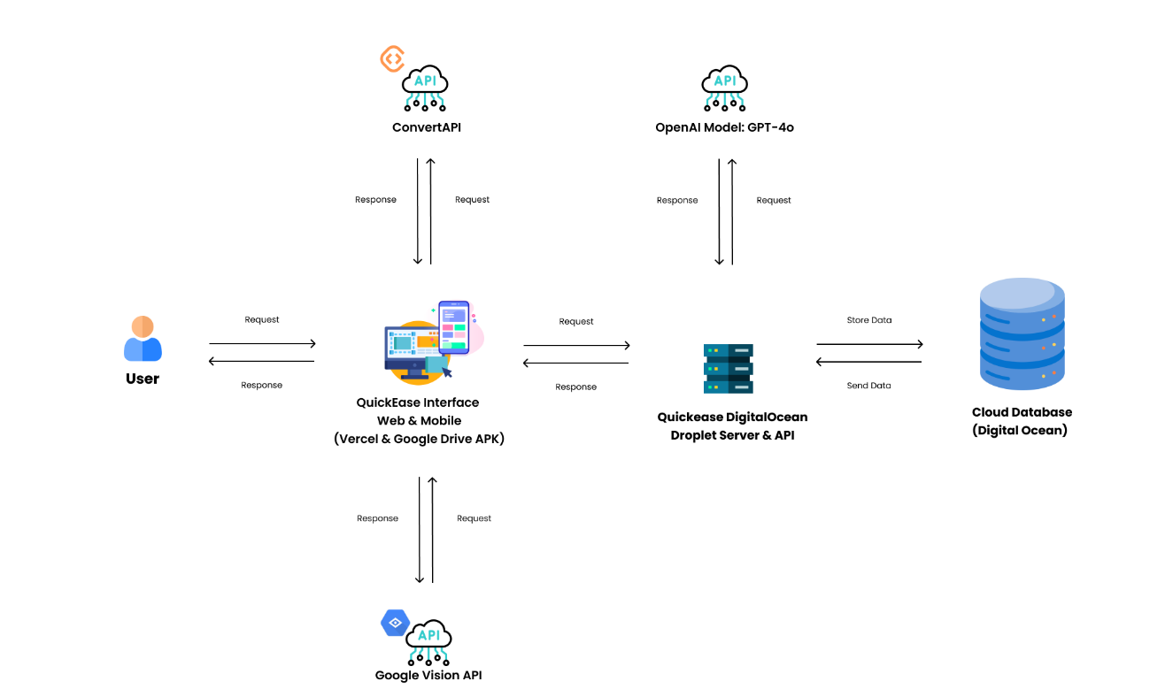

***Figure 4 | QuickEase’s System Architecture Diagram***

**3.3.2 USE CASE DIAGRAM**

The ***Figure 5*** shown on the next page, illustrates the Use Case Diagram of the QuickEase system, showcasing user interactions and the system's functionalities. At the center is the user, who initiates various actions such as Signing Up, Signing In, Signing Out, Managing Accounts, Managing Pomodoro Settings, Viewing Profile, and Generating Study Materials (Summaries, Flashcards, and Quizzes).

Users can Sign-Up an account but it requires to be verified first. Then Sign In with the verified account, and also recover their accounts via Forgot Password which can also be seen on the Sign-In Page, and Sign-Out anytime the user wishes to. In the Profile Page, users can view the achieved and the unachieved badges.

For the user’s study materials, users can generate Summaries from uploaded files, text inputs, or images, refine them through editing, and transform them into Flashcards or Quizzes. Users can then manage the contents of the generated flashcard sets based on the user’s preferences. Although, users can’t edit the generated quiz, users can retake the quiz however they want.

For the settings, users can enable the dark mode in the Application Settings, change their current password on the Account Settings, and set their preferred Pomodoro Settings. These allows the users to customize the appearance of the application, their password, and the pomodoro time sessions based on their preferences.

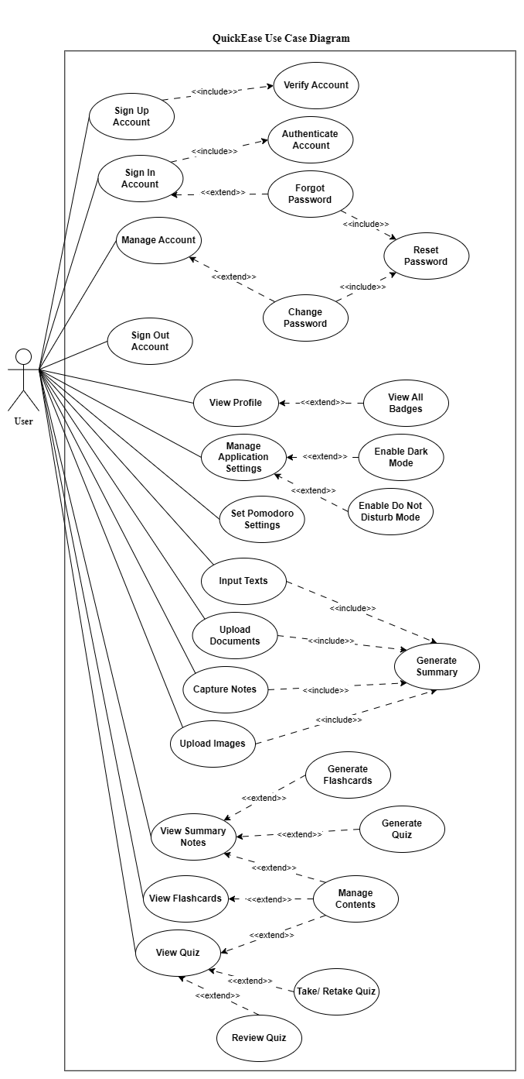

***Figure 5 | QuickEase Use Case Diagram***

**3.3.3 CONTEXT DIAGRAM**

The **Figure 6** shown on page 31, is a Context Diagram which outlines the interactions between the external entities such as the Users, and the third-party APIs, and the researchers’ system named QuickEase. The platform is designed to provide users with automatically generated content, including summary notes, flashcards, and quizzes, by leveraging OpenAI's NLP capabilities. Moreover, the platform features a Pomodoro Timer for productivity and a badge system to enhance user motivation and engagement.

Users can start using the QuickEase platform by signing up for an account, which involves inputting their name, email, and password and completing an email verification process. Upon verification, the system confirms the account setup. Users then sign in by providing their email and password for verification. For users who forgot or wish to change their password, they can also reset or simply change it. To verify the legitimate user, they must enter their email first to confirm their identity and the users will then receive a reset link at their respective email address, which the system processes and acknowledges.

QuickEase facilitates the generation of content through various input methods. These inputs are categorized into uploading text, images (jpeg, jpg, and png.), documents (pdf. doc. docx. ppt. and pptx.), or capturing images directly using their mobile phones. Text inputs are directly sent to OpenAI for summary generation. The image inputs are processed through the Google Vision API for text transcription before being sent to OpenAI. The PDFs and Word documents are handled by ConvertAPI, which converts them to transcribed text, while PPTs are converted to images through ConvertAPI and then processed by Google Vision API for transcription. The resulting text from these processes is sent to OpenAI for summary generation. For generating flashcards and quizzes, users can request these based on their existing summary notes stored in the system. The stored summary content is sent to OpenAI for generating flashcard or quiz content in JSON format, which is then process by our system and return the requested output to the user. Lastly, QuickEase allows users to adjust their Pomodoro Timer settings, these includes study time and break durations which are automatically saved to the cloud database. As the user interacts with the platform, such as accomplishing a specific requirement will then trigger the platform’s gamification system which rewards users a specific badge related to the user’s achievement.

Overall, the ***Figure 6*** on the next page, provides a clear, and a high-level overview of the researcher’s system. It visual representation highlights the user interactions within the system, and also shows what are the purpose of the external systems or the third-party APIs (OpenAI GPT-4o, Google Vision, and ConvertAPI)

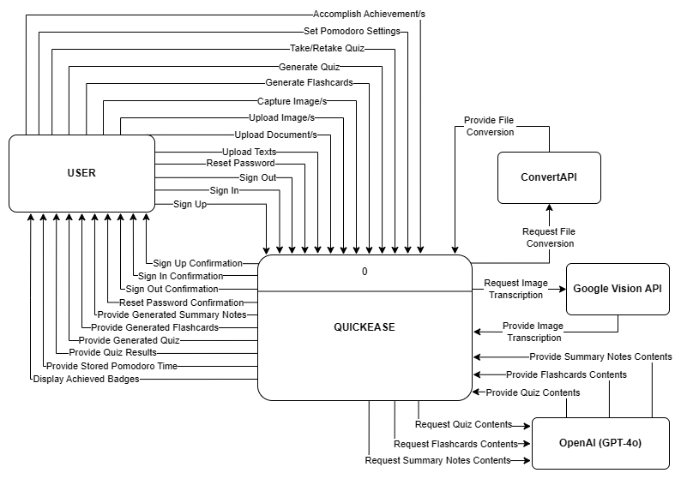

***Figure 6 | QuickEase Context Diagram***

**3.3.4 LEVEL-1 DATA FLOW DIAGRAM**

The **Figure 7** illustrates the Level 1 Data Flow Diagram for the QuickEase system, detailing the primary processes, data flows, data stores, and interactions between the QuickEase System and the Users, and the QuickEase System and the External Systems used, such as OpenAI GPT-4o, Google Vision, and ConvertAPI.

The Process 1.0 "Log In | Log Out | Sign-Up Account" process focuses on user authentication. Users can sign up for new accounts, log in to existing accounts, or log out securely. This process ensures proper validation and interacts with stored user data to handle account-related actions. Each action provides a confirmation, allowing users to verify the success of their requests.

The Process 2.0 "Generate Study Materials" process is the core functionality of the QuickEase system. This process enables users to upload different input types, such as text, images, or documents, to generate study aids like summaries, flashcards, and quizzes. Depending on the type of input, it is either processed by Google Vision for text extraction or ConvertAPI for document conversion before being sent to OpenAI GPT-4o for natural language processing. The system retrieves JSON-formatted outputs, such as summary contents, flashcards, and quiz questions, which are then stored for creating the generated study materials.

The Process 3.0 "Manage Account" allows users to manage their account details, as of the moment, only changing or resetting password feature has been developed. This process can still be further improved or changed by adding new features such as changing email address or deactivating an account. Each user action is still validated, and confirmation messages are provided for changing or resetting password for smooth account management.

The Process 4.0 "Manage Profile" process empowers users to customize their study sessions using a Pomodoro timer and track achievements through a badge system. This process manages stored Pomodoro settings that will be set according to the preferences of the users and monitors badge progress, providing users with an engaging and productive study experience. It also tracks achievement data and ensures users are rewarded for their efforts.

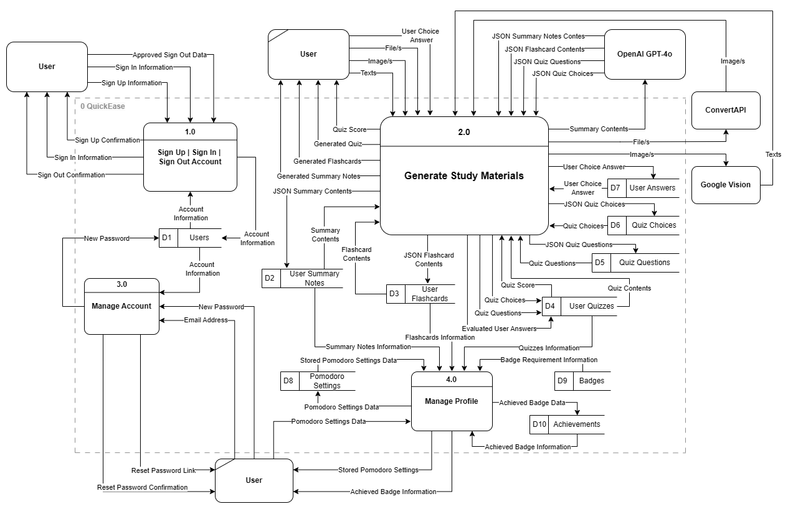

***Figure 7 | QuickEase Level-1 Data Flow Diagram***

**3.3.5 LEVEL-2 DATA FLOW DIAGRAM**

The **Figure 8** illustrates the Level 2 Data Flow Diagram for the QuickEase system, providing a detailed breakdown of the "Generate Study Materials" process into specific sub-processes namely, the Sub-Process 2.1 "Generate Summary", the Sub-Process 2.2 "Generate Flashcards", the Sub-Process 2.3 "Generate Quiz", and the Sub-Process 2.4 "Answer Quiz".

The Sub-Process 2.1 "Generate Summary" allows users to upload text, images, or documents for summarization. Images are processed by Google Vision for image transcription, and documents are handled by ConvertAPI for file conversion to either extract text directly which happens for PDF files, or return image/s if it’s a PPT file. Once processed, the extracted text is sent to OpenAI GPT-4o, which generates JSON-formatted summary contents. These summaries are then stored in the system for generating the requested summary notes.

The Sub-Process 2.2 "Generate Flashcards" utilizes the generated summaries to create flashcards. The system sends the summary contents data to OpenAI GPT-4o, which returns JSON-formatted flashcard contents. These contents are then processed and stored, providing users with organized flashcards tailored to their uploaded study materials.

The Sub-Process 2.3 "Generate Quiz" takes the summarized content and sends it to OpenAI GPT-4o to generate JSON-formatted quiz questions and multiple-choice options. The system formats this output into a quiz structure and stores it, ensuring users have access to interactive tests based on their summary notes.

The Sub-Process "Answer Quiz" (2.4) enables users to interact with the generated quizzes. Users submit their answers, which are evaluated by the system against the correct responses. The system calculates scores and provides a score feedback, allowing users to assess their understanding and track their learning progress effectively.

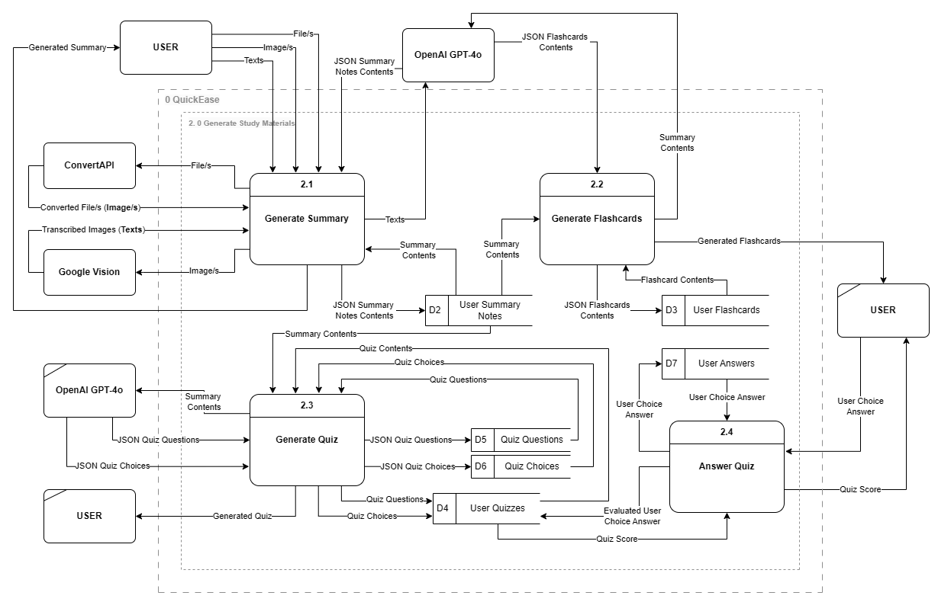

***Figure 8 | QuickEase Level-2 Data Flow Diagram of Process 2.0 (Generate Study Materials)***

**3.3.6 ENTITY RELATIONSHIP DIAGRAM**

The **Figure 9** presents the Entity Relationship Diagram (ERD) specifically Pjysical Data Model for the QuickEase system, which defines the database structure by detailing the entities, attributes, and relationships. This diagram highlights what data are stored within the system.

The central entity in the diagram is the Users entity, which stores vital user information such as userID, emailAddress, and password. This entity serves as the primary anchor for the database, establishing one-to-many relationships with other entities, such as UserSummaryNotes, UserFlashcards, UserQuizzes, PomodoroSettings, and Achievements, allowing users to interact with various features of the QuickEase system.

The UserSummaryNotes entity captures the summaries created by users, storing details like noteID, noteTitle, and noteContents. This entity ensures that users can manage their notes effectively and serves as a reference for generating flashcards and quizzes.

The UserFlashcards entity links to UserSummaryNotes, allowing flashcards to be created and stored based on specific summaries. It includes fields like flashcardID, frontCardText, and backCardText to organize flashcard content.

The UserQuizzes entity tracks quizzes generated and taken by users, with attributes such as quizSetID, quizScore, and quizDateCreated. It references noteID to associate quizzes with specific summary notes. Supporting this entity are QuizQuestions and QuizChoices, which store individual quiz questions and their respective multiple-choice options. The QuizQuestions entity links to UserQuizzes through the quizSetID foreign key, while QuizChoices connects to QuizQuestions via the quiztQuestionID foreign key, including the isAnswer attribute to mark the correct options. User responses are captured in the UserAnswers entity, which links to QuizChoices to store the user's selected answers.

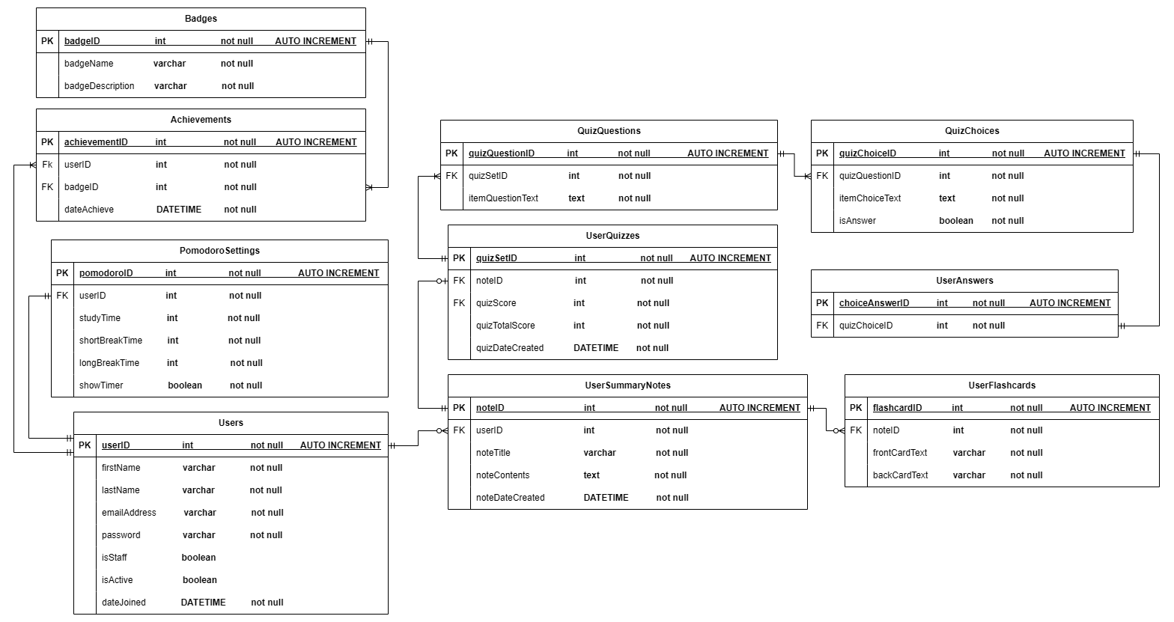

***Figure 9 | QuickEase Entity Relationship Diagram (Physical Data Model)***

**3.4 DEVELOPMENT AND IMPLEMENTATION**

The researchers utilize the following technologies and requirements to develop and implement their system, QuickEase.

**3.4.1 HARDWARE REQUIREMENTS**

The proposed system will require specific hardware configurations to ensure optimal performance. The development environment should run on Windows 10, providing a stable and familiar operating system for developers. The system should have at least 8GB of Random Access Memory (RAM) to handle the demands of running development tools frameworks smoothly. A dual-core processor or better is recommended to provide sufficient processing power for multitasking and running simulations. Additionally, a stable internet connection is necessary for accessing online resources, libraries, and version control systems such as Bitbucket.

***Table 2 | Hardware Specification Requirements***

|  |  |
| --- | --- |
| **Operating System** | Windows 10 |
| **Random Access Memory (RAM)** | 8GB |
| **Processor** | Dual Core Processor |
| **Internet Connection** | Required |

**3.4.2 SOFTWARE REQUIREMENTS**

To develop the QuickEase system, the software requirements include ReactJS for web applications and React Native for mobile application development, specifically targeting Android operating systems to provide a native experience. The Django framework will be utilized to build and design the backend due to its high-level Python web framework, which is known for its scalability and robustness. Microsoft Visual Studio Code will serve as the Integrated Development Environment (IDE) for development, while PostgreSQL will be chosen for its reliable and robust database functionality. Redux will handle state management for both web and mobile applications, and NPM will manage dependencies and packages. Axios will facilitate HTTP requests, while Postman will be employed for API testing, simulating requests and responses to enable efficient early-stage debugging. For version control and collaboration, Bitbucket, GitHub, and Git will ensure proper tracking and teamwork.

Tailwind CSS, an open-source CSS framework, will simplify the creation of custom user interfaces and applications quickly and efficiently. Meanwhile, NativeWind will bring utility-first styling to React Native applications, ensuring a consistent design language across platforms. React Joyride will enable guided tours, feature walkthroughs, and onboarding experiences for web applications. This tool will allow developers to highlight UI elements, provide step-by-step instructions, and guide users through features or workflows within the app, enhancing user experience. For text editing, React Quill will offer a customizable and extensible interface for building browser-based rich text editors. This modern WYSIWYG (What You See Is What You Get) editor will enable users to create, format, and manage content easily. On mobile platforms, React Native Pell Rich Editor will provide lightweight and effective WYSIWYG editing capabilities for Android, leveraging the simplicity and efficiency of the Pell text editor.

Additionally, React Native Walkthrough Tooltip will be integrated to display small pop-up elements that provide additional information or context about UI components when users interact with them. This feature will enhance onboarding, tutorials, or user guidance for specific workflows. React Native WebView will also be implemented to display web content seamlessly within the mobile application, enabling users to access external websites or embedded HTML content.

For image transcription, the Google Vision API will efficiently extract text from images. To handle document processing, ConvertAPI will facilitate file conversions across various formats, including DOCX, PPTX, and PDF. The OpenAI GPT-4 with natural language processing capabilities, allows comprehensive understanding for the referenced texts to generate a human-like text. Lastly, the backend is powered by Django and Django Rest Framework which will manage API interactions and process data with OpenAI's GPT-4 model for generating the contents for summary notes, flashcards, and quizzes.

* + 1. **TECHNOLOGIES USED**
* **React JS:** A popular JavaScript library for building User Interfaces, specifically for single-page applications.
* **React Native Expo:** A framework for building mobile applications with React. It allows developers to use JavaScript with React to build native-rendered mobile applications for Android.
* **Django:** A high-level Python web framework that encourages rapid development and provides clean, pragmatic design. Provides many built-in features—ORM, authentication, and an admin interface being just a few of the most popular.
* **Django Rest Framework (DRF):** The toolkit for all the Web APIs built with Django.
* **Microsoft Visual Studio Code:** A free source-code editor made by Microsoft. It comes with excellent support for a wide range of programming languages and frameworks, as well as features for debugging.
* **PostgreSQL:** A powerful, open-source object-relational database system that enjoys an unparalleled reputation due to its robustness, extensibility, and adherence to standards. It supports SQL and JSON querying, making it a good fit for most applications.
* **Redux:** A predictable state container for JavaScript applications. It is mainly used in conjunction with React for its application state.
* **NPM:** A package manager mainly for JavaScript. Still, it is usually used in managing the structure of libraries and their dependencies regarding Node.js projects, which inherit the sharing and reusability of code; it also manages the project's dependencies effectively.
* **Bitbucket:** A hosting service for source code repositories that use either Git or Mercurial. It is written using Python and uses the Django web framework. Bitbucket provides collaboratively hosted source code repositories.
* **Git:** A distributed version control system, also known as DVCS, made to handle projects running from small to very large with speed and efficiency. It allows for concurrent project development with version control and the ability to roll back to previous versions if needed.
* **Github:** A web-based platform that provides version control using Git, a distributed version control system. It is widely used for software development and version management, allowing multiple developers to collaborate on projects by tracking and managing changes to the codebase over time.
* **OpenAI:** An artificial intelligence research institute that develops and promotes friendly AI for the benefit of all humans.
* **Postman:** An API development tool. This makes it easy to develop, test, and document APIs since it provides an easy-to-use interface for making HTTP requests, validating responses, and automating API testing.
* **Tailwind:** An open-source CSS framework that helps users create custom user interfaces and applications quickly and easily
* **NativeWind:** A utility-first styling library that allows developers to use Tailwind CSS syntax within React Native applications, enabling a consistent design language across platforms.
* **Google Vision:** An application programming interface that enables image recognition and classification capabilities in applications, leveraging artificial intelligence to automatically label images and create metadata.
* **ConvertAPI:** A file conversion API that allows developers to convert files between different formats. It supports over 200 file formats, including documents, spreadsheets, presentations, images, and more. ConvertAPI is easy to use and can be integrated into any application.
* **React Joyride**: Used for creating guided tours, feature walkthroughs, and onboarding experiences in web applications. It allows developers to highlight elements on the user interface, provide step-by-step instructions, and guide users through features or workflows within an app.
* **React Quill**: An open-source, modern WYSIWYG (What You See Is What You Get) editor that provides a powerful, customizable, and extensible interface for building text editing applications in the browser.
* **React Native Pell Rich Editor**: A React Native library for creating a rich text editor in mobile applications. It provides a simple, easy-to-use interface for building rich text editing features on iOS and Android platforms. The library is based on the Pell rich text editor, which is a lightweight and minimal WYSIWYG (What You See Is What You Get) editor designed for the web.
* **React Native Walkthrough Tooltip:** A React Native library used to create tooltips, which are small pop-up elements that provide additional information or context about a UI element when the user interacts with it. It is often used in onboarding flows, tutorials, or to guide users through specific features or steps in an app.
* **React Native WebView:** A versatile component in the React Native ecosystem, designed to enable the integration of web content within mobile applications. It allows developers to embed external websites or local HTML content seamlessly within a mobile app, providing a bridge between native application components and web-based interfaces.
* **Font Awesome**: An open-source icon library and toolkit that provides a wide range of scalable vector icons.
* **Annotated Types**: Provides annotations for Python type hints.
* **AnyIO**: Async networking and concurrency framework.
* **ASGIref**: ASGI reference library for Django and other ASGI frameworks.
* **Certifi**: Provides SSL certificates for secure HTTP connections.
* **CFFI**: C Foreign Function Interface for Python.
* **Charset Normalizer**: Charset detection and encoding normalization library.
* **Colorama**: Cross-platform terminal text coloring support.
* **Cryptography**: Provides cryptographic recipes and primitives for Python.
* **Defused XML:** Securely parse XML to prevent vulnerabilities
* **Distro**: Detects Linux distribution details.
* **Django-CORS-Headers**: Easily add Cross-Origin Resource Sharing (CORS) headers to Django responses.
* **Django-Templated-Mail**: Email templates for Django using templating engines.
* **Django Rest Framework SimpleJWT**: JSON Web Token (JWT) authentication support for DRF.
* **Djoser**: RESTful authentication system for Django projects.
* **ExceptionGroup**: Handles groups of exceptions raised in Python.
* **H11**: A Pure-Python implementation of HTTP/1.1 protocol for async libraries.
* **HTTPCore**: Core components for HTTP clients in Python.
* **HTTPX**: HTTP client with support for async and sync APIs.
* **IDNA**: Support for internationalized domain names in Python.
* **Jiter**: A library to add jittering to execution times.
* **OAuthLib**: Implements OAuth1 and OAuth2 for Python applications.
* **OpenAI**: SDK for interacting with OpenAI’s APIs, such as GPT models.
* **Psycopg2**: PostgreSQL adapter for Python to interact with databases.
* **PycParser**: C parser and abstract syntax tree (AST) generator in Python.
* **Pydantic**: Data validation and settings management using Python type hints.
* **Pydantic Core**: Core utilities for high-performance Pydantic features.
* **PyJWT**: Python library for creating and verifying JSON Web Tokens (JWT).
* **Python-Dotenv**: Load environment variables from .env files in your project.
* **Python3-OpenID**: Support for OpenID authentication in Python projects.
* **Regex**: Provides advanced regular expression capabilities.
* **Requests**: A simple HTTP library for Python developers.
* **Requests-OAuthLib**: OAuth support for the popular Requests library.
* **Sniffio**: Detect the async library runtime in use.
* **Social-Auth-App-Django**: Adds social authentication to Django projects.
* **Social-Auth-Core**: The core library for implementing social authentication.
* **SQLParse**: A library for parsing and formatting SQL queries.
* **Tiktoken**: Tokenizer for use with OpenAI’s GPT models.
* **TQDM**: A fast, extensible progress bar for loops and iterables.
* **Typing Extensions**: Backports Python typing features for older versions.
* **TZData**: Timezone information for Python applications.
* **Urllib3**: HTTP client with advanced features like connection pooling
* **Whitenoise**: Simplifies static file serving for WSGI applications

|  |  |
| --- | --- |
| **Frontend Framework** | React JS, React-Native |
| **Backend Framework** | Django, Django Rest Framework |
| **IDE** | Microsoft Visual Studio Code |
| **Database** | PostgreSQL |
| **Frontend Packages** | Redux, NPM, Axios, React Joyride, React Quill, Pell Rich editor, React Native Walkthrough Tooltips, React Native WebView, Font Awesome |
| **Backend Libraries** | annotated-types, anyio, asgiref, certifi, cffi, charset-normalizer, colorama, cryptography, defusedxml, distro, Django, django-cors-headers, django-templated-mail, djangorestframework, djangorestframework-simplejwt, djoser, exceptiongroup, h11, httpcore, httpx, idna, jiter, oauthlib, openai, psycopg2, pycparser, pydantic, pydantic_core, PyJWT, python-dotenv, python3-openid, regex, requests, requests-oauthlib, sniffio, social-auth-app-django, social-auth-core, sqlparse, tiktoken, tqdm, typing_extensions, tzdata, urllib3, whitenoise |
| **Version Control** | BitBucket, Git, Github |
| **Generative Pre-Trained Transformer** | OpenAI GPT 4o Model |
| **API-Tester** | Postman |
| **Optical Character Recognition** | Google Vision / Cloud Vision |
| **File Conversion API** | ConvertAPI |

***Table 3 | Software Specification Requirements***

**3.5 TESTING AND EVALUATION OF THE SYSTEM**

After developing the system, the researchers will test and identify the functionality and usability of the system to profile the functions and features that are functional. The researchers would follow standards such as the System Usability Scale (SUS) and International Standard Organization (ISO) 25010 in formulating questions that would evaluate their system. The researcher also suggests applying the method called “Pilot Testing” to further evaluate the usability and functionality of the system.

**3.5.1 PILOT TESTING**

The pilot testing of the QuickEase system will begin by deploying beta versions of its web and mobile applications to a selected group of students at the University of Science and Technology of Southern Philippines. The participants will be chosen using convenience sampling from two distinct colleges which are the College of Information Technology and Computing and the College of Science and Technology Education. This approach ensures the selection of participants who are readily available and relevant to the study's objectives.

Thirty students will be selected from the College of Information Technology and Computing due to their technical background which may provide valuable suggestions for system improvement. Additionally, another thirty students will be chosen from the College of Science and Technology Education to benefit from courses and programs that require detailed study materials and study techniques in which they can potentially provide unbiased and comprehensive feedback because some of these students may have no or little technical background.

Selected participants will receive detailed instructions on accessing and utilizing the beta versions. A testing session will be conducted to allow them to interact with the core features of QuickEase, including automated summarization, flashcard generation, self-assessment tools, Pomodoro technique, and gamification elements. This session will be monitored to collect data on usability and functionality performance. Participants will be encouraged to extensively use all aspects of the application and provide continuous feedback on their experiences.

The feedback collection process will employ both qualitative and quantitative methods. Participants will complete the System Usability Scale and ISO 25010 survey questionnaire to provide detailed insights. This testing aims to identify usability issues, technical bugs, and areas for system enhancement.

Following the testing phase, the collected feedback will be analyzed to identify common issues, which will inform necessary refinements and optimizations. This iterative process is crucial for evaluating and enhancing the QuickEase system's usability and functionality.

**3.5.2 System Functionality Testing**

The Table 4 contains the features that have to be tested by the system users, the descriptions of how these features operate, how one can test the features, the expected results of the features, as well as the state. During the evaluation process, before allowing the systems operator to test the features, the researchers would check each of the functionalities. The test step description shows how each functionality should be tested, while the expected result gives the outcome if everything goes right and no issues or failures happen. If the actual result correlates with the expected result, then the status or remarks assigned will be "PASSED," which means that what functionality does is how it should work. Otherwise, it would be "FAILED," in which case it might have something wrong with the functionality.

***Table 4 | QuickEase Functionality Testing***

|  |  |  |  |  |
| --- | --- | --- | --- | --- |
| **Tests** | **Description** | **Tests Step** | **Expected Result** | **Status** |
| **Login** | The user should be able to login with user credentials such as email and passwords. | Open the application and click the “Sign in” button. | The user can successfully login. | PASS/FAIL |
| **Signup** | The user should be able to sign up with requirements needed (first name, last name, email address, password, confirm password) and acceptance of the application’s terms and conditions. | Click the “Join Now” button. Fill out necessary requirements first name, last name, email address, password, confirm password) , accept terms and conditions and click “Signup”. Go to the provided email address. Select the email sent by QuickEase Team. Click the “Account Activate”. | The user can successfully create an account. | PASS/FAIL |
| **Reset Password** | The user should be able to reset the password. | Navigate to the login page and click “Forgot Password”. Enter the account’s valid email address. Go to your email and click the provided reset link sent by QuickEase Team. Enter a new password. Click the “Confirm” button to reset your password. | Users can successfully change or reset passwords. | PASS/FAIL |
| **Dashboard** | The user should be able to access the landing page. | Access the system and verify if the dashboard is accessible. | The user can access the dashboard | PASS/FAIL |
| **Generate Summary Notes** | Users should be able to generate summary notes (being uploaded images or documents , captured notes, and manually text inputs). | Navigate to each function (Upload Image, Captured Notes, Upload documents, Input text  manually) and click “Generate”. | The user can generate summary Notes. | PASS/FAIL |
| **Input Text** | The user should be able to input/paste text manually | Proceed to the input text function and type manually or paste texts to be summarized then click “Generate”. | The user can  input or paste text manually. | PASS/FAIL |
| **Upload documents** | The user should be able to upload documents (e.g. pdf .docx .ppt). | Proceed to the upload documents function. Then browse the file folder and choose a document of learning materials to be summarized. | The user can  upload documents of learning materials. | PASS/FAIL |
| **Capture Notes** | The user should be able to capture notes. | Proceed to capture notes function. Position the camera over the learning materials  (e.g., a printed page or handwritten notes), then take a picture of learning materials to be summarized | The user can  capture notes of learning materials. | PASS/FAIL |
| **Upload Image** | The user should be able to upload an image of their learning materials. | Proceed to the upload image function. Then browse the gallery and choose an image of learning materials to be summarized. | The users can upload an image. | PASS/FAIL |
| **View Notes** | The user should be able to view the generated Summarized notes | After clicking “Generate”, it will redirect to your notes. | The user can   view the summary notes | PASS/FAIL |
| **Edit Notes** | The user should be able to edit the summarized notes. | Click the pencil icon button to start the editing then click “Save” to save changes. | The note’s content can be edited and saved. | PASS/FAIL |
| **Delete Notes** | The user should be able to delete a summary note. | Select a specific note and click the ellipsis menu then press the “delete” button. | The user can successfully delete summary notes. | PASS/FAIL |
| **Generate flashcards** | Users should be able to generate flashcards from summarized notes. | After notes creation. Click the “Generate Flashcards” button. Press “Confirm” to generate flashcards. | The user can generate a set of flashcards | PASS/FAIL |
| **View FlashCards** | Users should be able to view generated flashcards. | After clicking “Confirm” from the generate flashcard function, it will redirect to your set of flashcards | The user can view the set of flashcards. | PASS/FAIL |
| **Edit flashcards** | Users should be able to customize the flashcards after generation, such as editing content and adjusting the number of cards. | After flashcards are generated, to edit a flashcard’s content or number click the “pencil” icon. Customize the flashcards as needed and save the changes. | The user can successfully modify the content or number of flashcards and save its changes. | PASS/FAIL |
| **Generate Multiple -**  **choice Quiz** | Users should be able to generate a multiple-choice quiz from summarized notes. | Navigate back to your summarized notes  and click “Generate Quiz”. Press “Confirm” to generate a multiple-choice quiz. | The user can generate a multiple-choice quiz. | PASS/FAIL |
| **Review Quiz** | Users should  be able to review  the quiz | After answering the quiz. Click “Review” to review the test/quiz. | The user can review their Test/Quiz. | PASS/FAIL |
| **Retake Quiz** | Users should be able to retake the quiz. | Click “Retake” to answer the quiz again. | The user can retake the quiz. | PASS/FAIL |
| **View Badges** | The user should  be able to view their acquired badges. | Navigate to the user profile by clicking the “Profile” icon. Tap “View All Badges” under the badge section to view all badges earned. | The user can successfully view their earned badges | PASS/FAIL |
| **Pomodoro Timer** | The user should be able to use the Pomodoro timer. | Click “Pomodoro Timer” then “Start Timer” | The user successfully used the timer. | PASS/FAIL |
| **Disable/**  **Enable Pomodoro Timer** | The user should  be able to disable/enable Pomodoro timer. | Click “The Pomodoro Technique” under the Study Technique section.  Tap the toggle to enable/disable the pomodoro timer. | The user can successfully disable/enable Pomodoro Timer. | PASS/FAIL |
| **Adjust Pomodoro Time** | The user should  be able to adjust pomodoro Time. | Enter the necessary fields (study session, short break, long break). Changes will be saved automatically. | The user can successfully adjust Pomodoro Timer | PASS/FAIL |
| **Enable/**  **Disable**  **Dark Mode** | The user should  be able to disable/enable  Dark Mode | Navigate to Profiles by clicking the profile icon. Click the setting icon located at the top right corner then press the toggle enable/disable Dark Mode. | The user can  disable/enable Dark Mode. | PASS/FAIL |
| **Logout** | The user should be able to log out their accounts. | Click the “Logout” button. | The user can logout. | PASS/FAIL |

**3.5.3 System Evaluation Standards**

1. **System Usability Scale (SUS)**

It is one of the best-known standardized, low-cost tools and reliable usability rating scales. It focuses on giving a ten-item questionnaire with five response options for respondents: Strongly agree, Agree, Neutral, Disagree, and Strongly disagree. It was developed by John Brooke in 1986 as a “quick and dirty”, yet reliable tool for measuring the usability of a wide range of products and services, including hardware, software, mobile devices, websites, and applications.

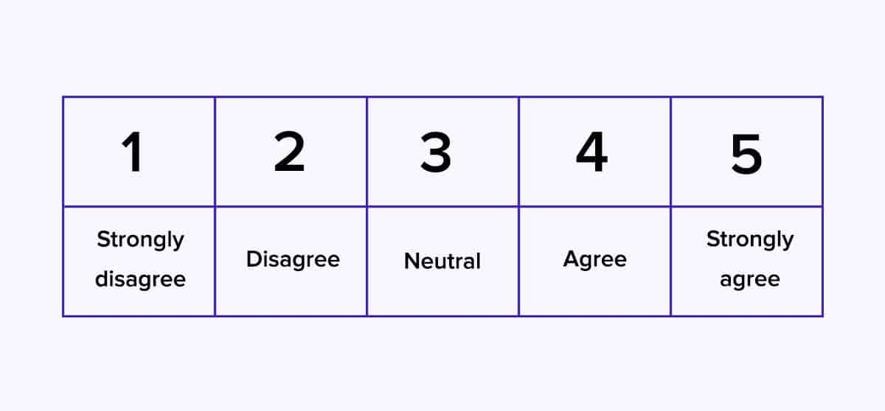

***Figure 10.0 Likert Scale***

The researchers will be using these steps to calculate the scores of each respondent’s System Usability Scale:

1. For odd-numbered questions (Raw Score = Response -1)
2. For even-numbered questions (Raw Score = 5 - Response)
3. Sum all the raw scores from each respondent and multiply it by 2.5.
4. Then it will give you the SUS Score which converts the range of possible values from 0 to 100 instead of from 0 to 40.

SUM Score = (Sum of adjusted scores) * 2.5.

**Aggregate SUS Score for all respondents:**

Compute the Average SUS Score: Add all the SUS Scores and divide by the total number of respondents.

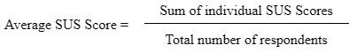

1. **ISO 25010**

The ISO 25010, Systems and Software Engineering—Systems and software quality requirements and evaluation (SQuaRE)—System and software quality models, is an international standard dealing with the quality model for evaluating software products. This contains characteristics and sub-characteristics of quality in software product evaluation and its use, such as functional suitability, reliability, usability, and security, among other traits. This standard will help to find areas for software improvement and ensure developed software meets user needs and expectations, offering practical guidance on applying such models of quality effectively. It also uses a five-response option just like the Likert scale.

**ISO 25010 score Calculation**

Calculate the Average Score for Each Question

For each question in the ISO 25010 questionnaire, calculate the average score using this formula:

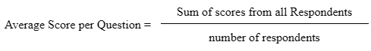

Calculate the average score for each category.

Once the average score for each question is calculated, group the questions into their respective category (e.g. functional suitability, performance efficiency, etc). Then calculate the average for the category using this formula:

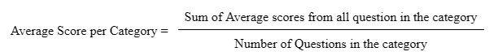

**3.6 SYSTEM DEPLOYMENT**

The QuickEase Web Front-End was deployed on the Vercel Platform, this allows users to access the platform using a modern web browser on different devices, such as laptops and smartphones. The mobile application was built by Expo Go and made available to download via Google Drive through a secured link or a secured QR code. Lastly, the QuickEase Back-End along with the system’s database was deployed on the Digital Ocean.

**CHAPTER IV**

**RESULTS AND DISCUSSIONS**

This chapter will discuss the Front-End of the system, the system evaluation results computation, and interpretations. The testing results of the evaluation in terms of Functionality and Usability will also be discussed.

**4.1 Generating Summaries**

The Figure 11 collectively showcase the user interfaces for generating and managing summaries in QuickEase. Users can create summary notes using three input methods: Input Text, where users can type or paste text; Upload Documents, supporting file formats like PDF, DOC, DOCX, PPT, and PPTX; and Upload Images, compatible with JPG, JPEG, and PNG formats. All inputs must contain at least 200 words and not exceed 10,000 characters or 10MB in size.

The Home Page is shown with both expanded and collapsed navigation bars, offering flexibility in viewing options. A step-by-step guide at the bottom of the page assists users in generating summaries, while an in-app tutorial provides an interactive walkthrough for ease of navigation. A loading screen appears during the summary generation process.

The generated summaries are organized into Introduction, Overview, and Key Points/Key Concepts sections. Users can utilize features like "Generate Flashcards," "Generate Quiz," and "Edit Summary" to customize their study materials. The editing interface allows users to modify content with formatting tools and save or discard changes.

The Summary Notes Page lists all created summaries with features like a page indicator, sorting, and search functions for easy navigation and management. These interfaces streamline the process of creating and organizing study materials efficiently.

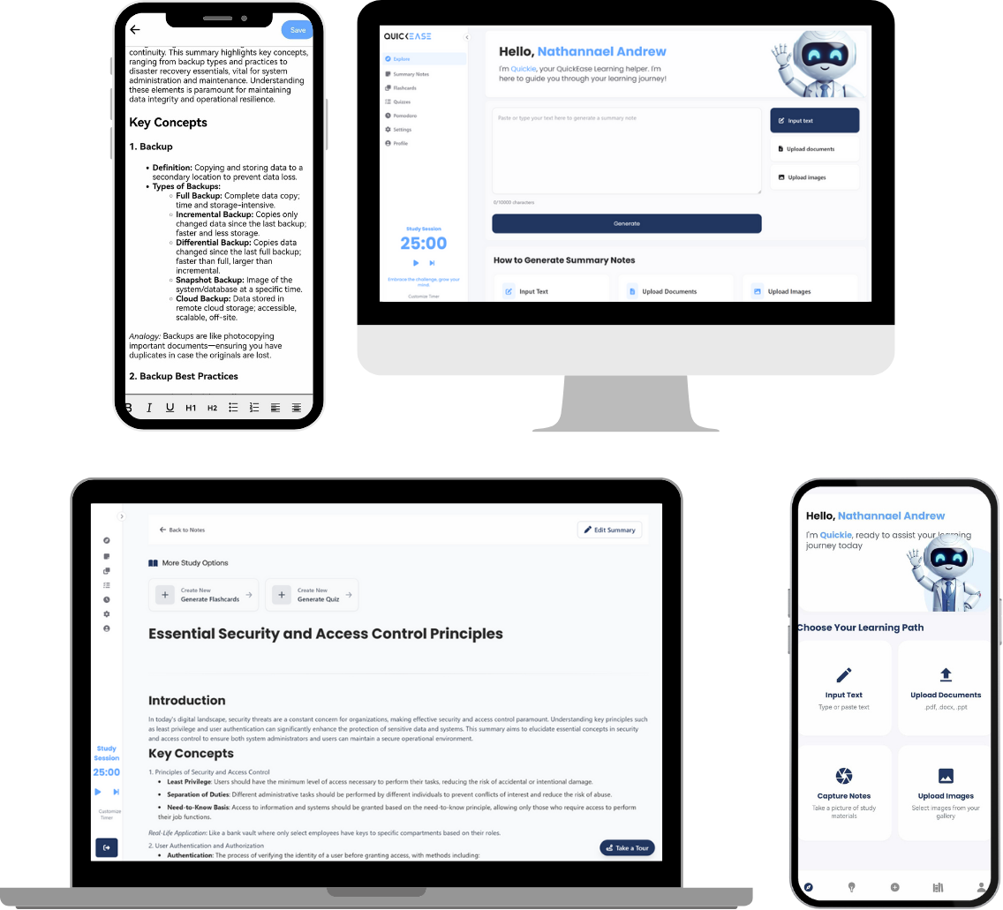

***Figure 11 | Generating Summaries User Interfaces***

**4.2 Generating Flashcards**

The Figure 12 highlights the user interfaces for generating and managing flashcards in QuickEase. Users begin the process by clicking the "Generate Flashcards" button, prompting a confirmation modal and loading screen to appear during the generation process.

The Generated Flashcards Page displays a single interactive flashcard at the top, with the remaining flashcards listed below for easy selection and navigation. Users can flip cards, navigate between them using keyboard shortcuts, and access editing options through the "Edit" button. An in-app tutorial guides users on these features to ensure smooth interaction.

The Edit Flashcards Section provides robust customization options, allowing users to add, edit, or delete flashcards individually or as a complete set. Users can input terms and definitions, refine content, and save changes or start fresh by deleting all cards. An embedded tutorial helps users understand the editing tools and features.

The Flashcards Page organizes all user-generated flashcard sets, offering functionalities like a page indicator, sorting options, and a search bar to locate specific sets quickly. These interfaces streamline the creation, editing, and management of flashcards, making study sessions more efficient and engaging.

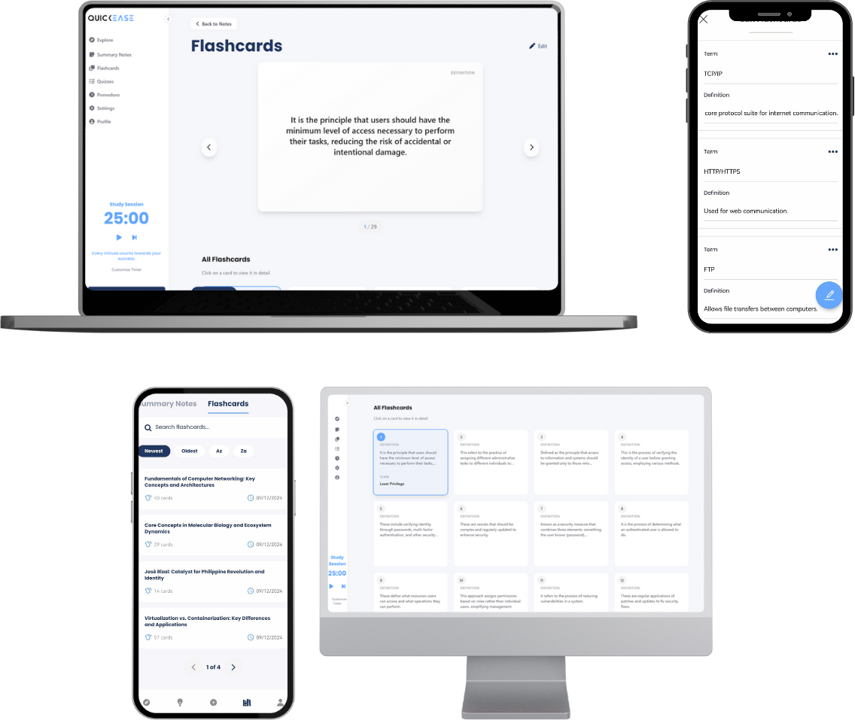

***Figure 12 | Generating Flashcards User Interfaces***

**4.3 Generating Quizzes**

The Figure 13 highlights the user interfaces for generating and managing quizzes in QuickEase. Users initiate quiz generation by clicking the "Generate Quiz" button, which triggers a confirmation modal and a loading screen.

The Generated Quiz Page features a Quiz Navigator on the left, allowing users to navigate seamlessly between items by clicking their corresponding numbers. The quiz format is multiple-choice, with each question offering four options and only one correct answer. Selected answers are highlighted, and the Quiz Navigator dynamically updates—answered items appear in green, while unanswered items remain uncolored. Users can also flag questions for review, changing the corresponding item in the navigator to orange for quick identification.

The quiz results page showcases outcomes for completed quizzes, displaying the total number of correct and incorrect answers. Users can access buttons for "Review Answers", which allows them to revisit the quiz with their answers highlighted, or "Retake Quiz", where choices are randomized for a new attempt.

The Review Page provides detailed feedback, enabling users to expand and view correct answers and all available choices. Lastly, the Quizzes | Quiz History Page organizes all generated quizzes, offering navigation tools like a page indicator, sorting options, and a search function for efficient quiz management. These interfaces enhance the user's experience in generating, taking, and managing quizzes effectively.

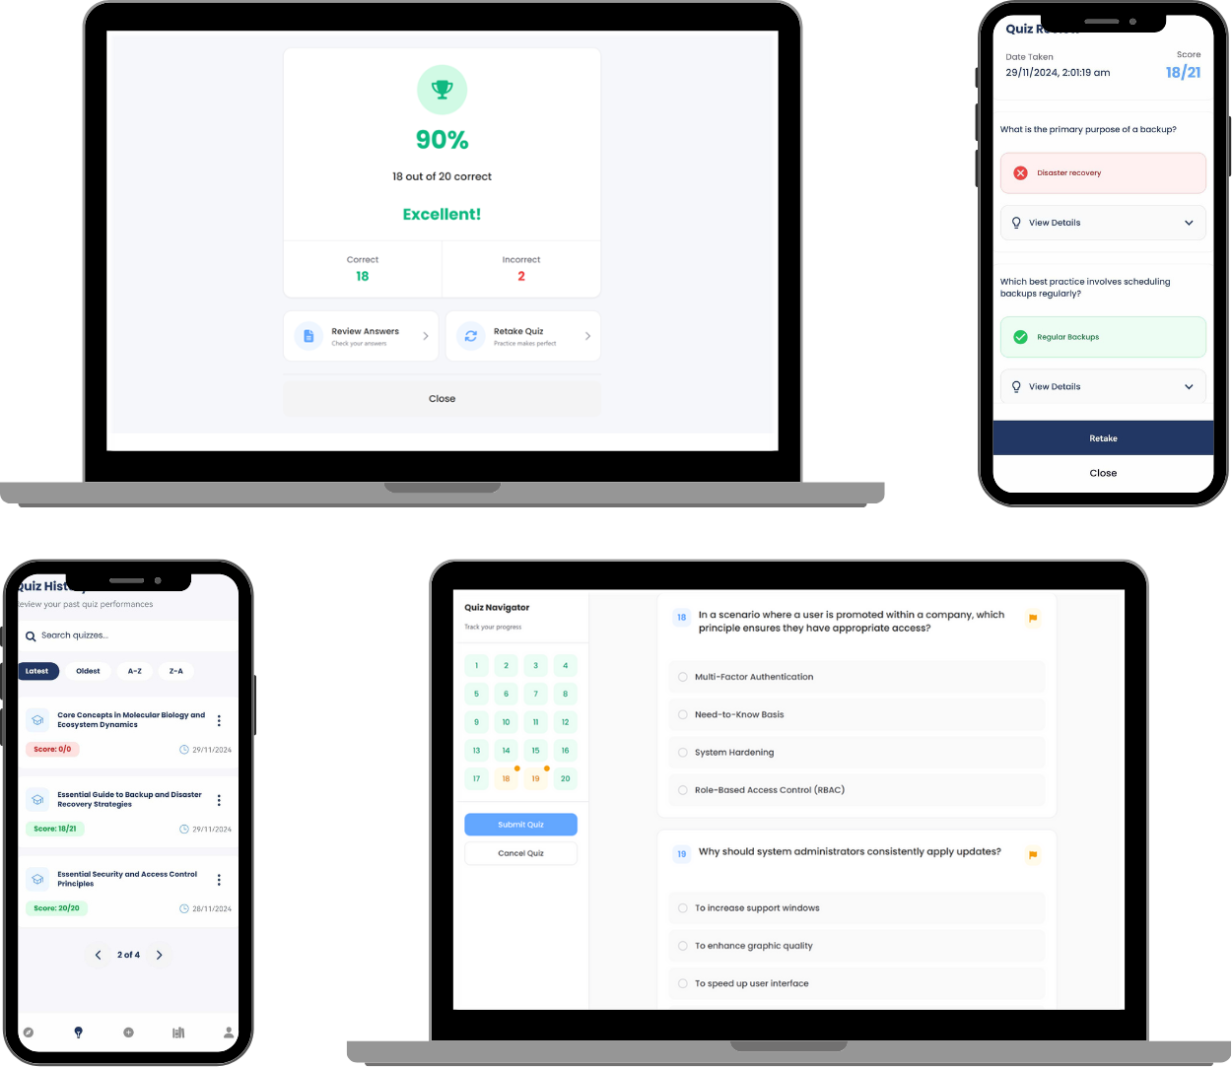

***Figure 13 | Generating Quizzes User Interfaces***

**4.4 Pomodoro Timer and User Badges**

The Figure 14 collectively showcase the user interfaces for managing the Pomodoro Timer, Profile Page, and achievement system in QuickEase. The Pomodoro Timer Settings allow users to customize study and break durations, enable or disable the timer, and access a guide on effective use of the technique. Default settings of 25-minute study sessions, 5-minute short breaks, and 15-minute-long breaks can be adjusted for personalized time management. Disabling the timer offers a cleaner interface for users who prefer not to utilize this feature.

When enabled, the Pomodoro Timer integrates seamlessly into sections like Summary Notes and Flashcards, with a countdown timer guiding study sessions. Users are alerted to session transitions through a Break Time Modal featuring an alarm and a Web Push Notification, ensuring users remain on track even when browsing other tabs.

The Profile Page highlights user information, including study material statistics and achieved badges, fostering motivation and tracking progress. Achieved badges appear in color, while unachieved ones are grayscale. Badge descriptions provide hints for earning them, and pop-up notifications celebrate new achievements, enhancing user engagement.

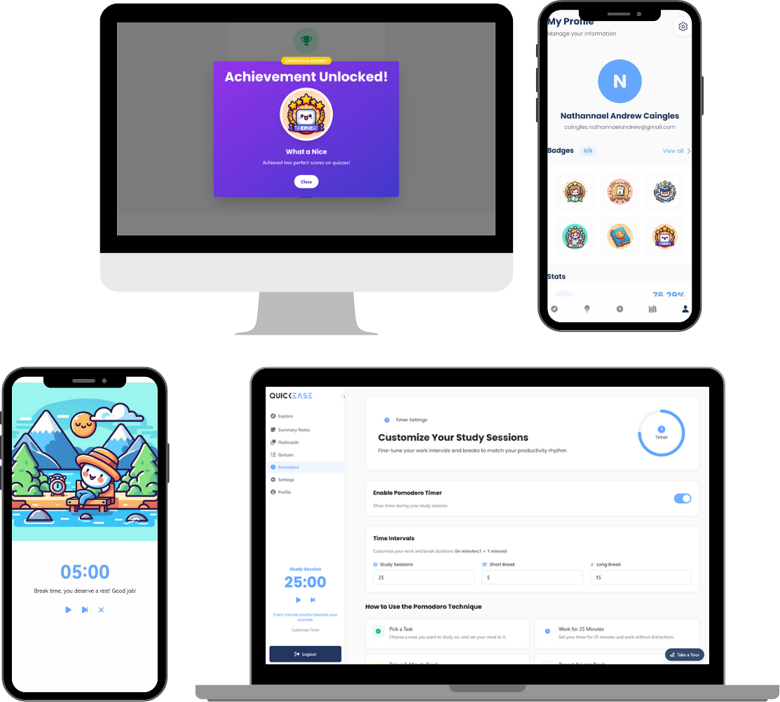

***Figure 14 | Pomodoro Timer and Badge System***

**4.5 System Evaluation**

**4.5.1 System Usability Scale (SUS)**

***Table 5 | Likert Scale***

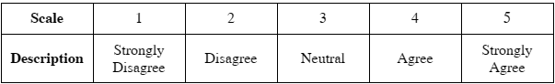

The System Usability Scale (SUS) is a widely utilized and reliable tool for evaluating the usability of a system, interface, or product. It provides a global assessment of user satisfaction and system usability through a ten-item questionnaire. It is considered an industry standard because of its simplicity, versatility, and robustness in assessing user-centered design. It is also based on a Likert scale design. The respondents rate their level of agreement or disagreement with a list of statements about the system. It uses a five-point scale, ranging from "Strongly Disagree" (1) to "Strongly Agree" (5) as shown in the Table 5.0 below.

The table 6.0 shows the questions used for assessing the system usability given that the odd-numbered questions being positive and even-numbered questions being somewhat negative.

***Table 6 | SUS Questionnaire***

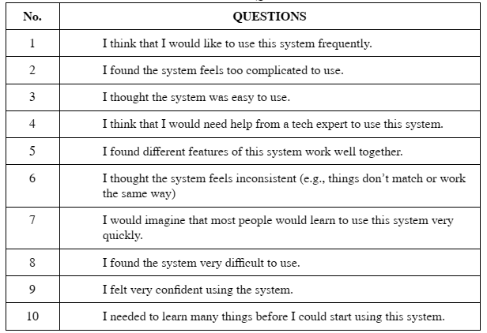

The responses from the users to the SUS questions, along with the computed SUS scores, are summarized in **Table 7.0**. Using the formula outlined in Chapter 3, the researchers calculated an overall SUS score average of 82.29. When comparing results by college, participants from the College of Science and Technology Education (CSTE) had an average SUS score of 76.17, which is lower than the 88.42 average SUS score achieved by participants from the College of Information Technology and Computing (CITC). The disparity in SUS scores between CSTE (76.17) and CITC (88.42) participants may be attributed to differences in prior technology experience. According to **Sauro (2013),** users with more experience tend to rate systems higher, with repeat or experienced users giving scores up to 11% or higher than those with limited experience. This suggests that CITC participants, with greater technology exposure, found the system significantly more usable than CSTE participants, who likely have no or limited experience with technology.

According to **Brooke (2013),** the System Usability Scale (SUS) has demonstrated consistent reliability and validity over the years, making it a robust tool for usability evaluations across various technologies. As shown in Table 8.0 below, the outcome is categorized as "Acceptable" with an adjective rating of "Excellent." Brooke (2013) also notes that a SUS score of 70 is around the average score of 68, which corresponds to the 50th percentile, indicating that the system's usability is considered above average. Therefore, with a SUS score of 82.29, it suggests that the system's usability is significantly above average, indicating a high level of user satisfaction and ease of use.

***Table No. 7 | SUS Responses and Computed Scores***

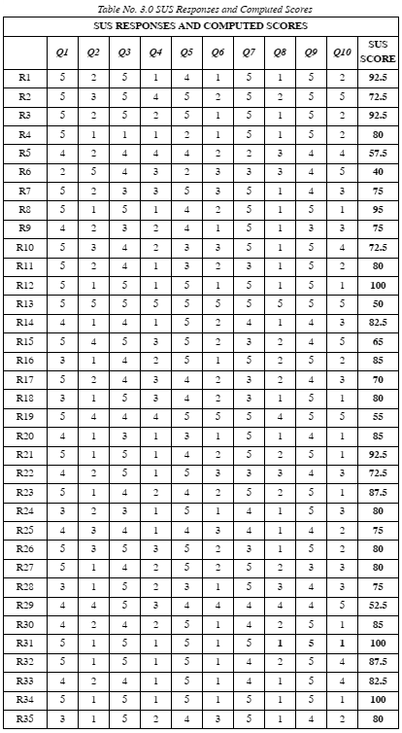

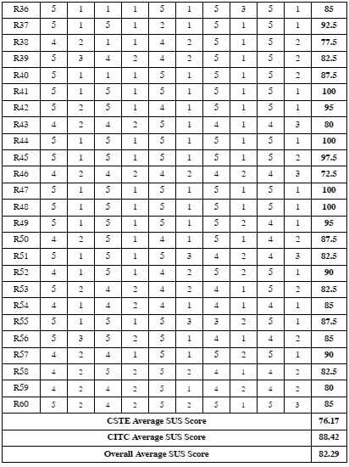

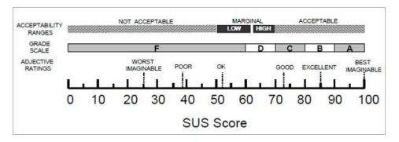

***Figure 15 |*** *Based on grade rankings of SUS scores from “Determining What Individual SUS Scores Mean: Adding an Adjective Rating Scale,” by A. Bangor, P.T. Kortum, and J.T. Miller, 2009, Journal of Usability Studies, 4(3), 114–123. Reprinted with permission.*

***Table No. 8 | SUS Interpretation Score***

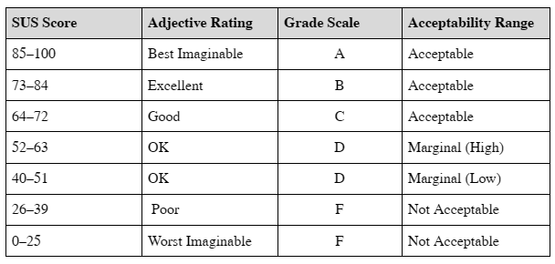

**4.5.2 ISO 25010**

ISO/IEC 25010 is an international standard designed to evaluate and ensure the quality of software products. It assesses various software characteristics, including functional suitability, reliability, usability, security, and more. By identifying improvement areas and aligning with user expectations, the standard helps maintain high-quality software outputs. The researchers used the formula as outlined in Chapter 3 to calculate the mean scores of each characteristic and its overall mean.

The **Figure 16** illustrates the ISO product quality model that is used to evaluate the system. The researchers will mainly focus on functional suitability, performance efficiency, usability/interaction capability, reliability, and security.

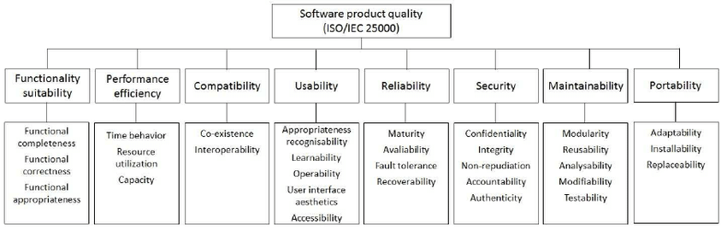

***Figure 16 | ISO Product Quality***

Based on the **Table 9,** the system demonstrates high functional suitability with an overall mean of 4.68, reflecting strong performance in functional correctness (4.68) and appropriateness (4.70), while functional completeness (4.67) shows slight room for improvement, particularly noted by CSTE users (4.47) compared to CITC (4.87). This means that the system meets the expectation of what user’s need in terms of its functionalities and still has room for further improvements.

**Table 9 | Functional Suitability Mean Result**

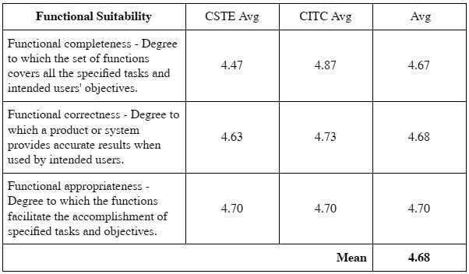

**Table 10.0** shows the system's performance efficiency that has garnered an overall mean of 4.08, with good ratings in capacity (4.22) and resource utilization (4.12), while time-behavior (3.9) shows room for improvement, especially noted by CSTE users (3.67). It suggests that the processing time for summary note, flashcards, and quiz generation could be improved. However, the response rate may vary depending on how stable the internet is and how lengthy or well organized the uploaded documents and images are. Overall, it is a good result with room for improvement.

***Table 10 | Performance Efficiency Mean Result***

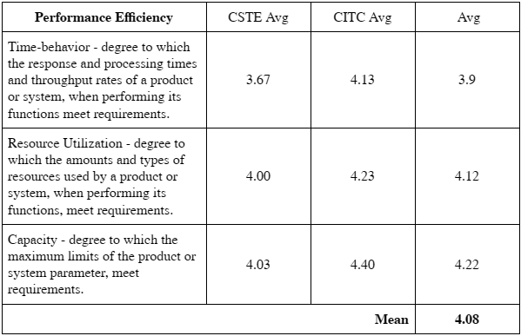

The **Table 11** below shows that system demonstrates strong usability with an overall mean of 4.56, excelling in appropriateness recognizability (4.63) and operability (4.62), while accessibility (4.42), especially noted by CSTE users (4.30). As noted in the SUS results, users with greater exposure to technology, such as CITC users, tend to rate system usability higher than those with less exposure, like CSTE users. Therefore, the lower ratings from CSTE users compared to CITC users are reasonable and align with expected trends. Overall, the results are positive but also indicate opportunities for further system improvement.

***Table 11 | Usability Mean Result***

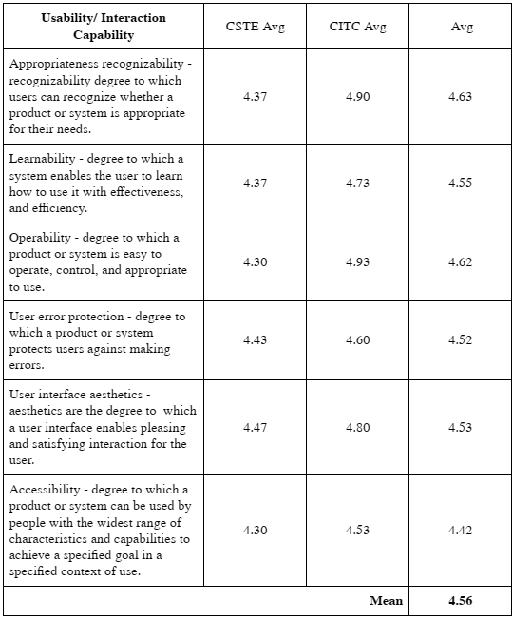

Based on **Table 12**, the system's reliability scored an overall mean of 4.16, with high ratings in availability (4.70) and maturity (4.38), **demonstrating** dependable performance under normal operations. However, lower scores in fault tolerance (3.68) and recoverability (3.88) highlight areas for improvement, especially in handling and recovering from failures. Slow internet connection may be attributed to these and users may perceive delays are the system's fault or failure. It suggests the importance of optimizing the system to handle connectivity issues effectively. Overall, the results are good and such areas discussed could be improved.

***Table 12 | Reliability Mean Result***

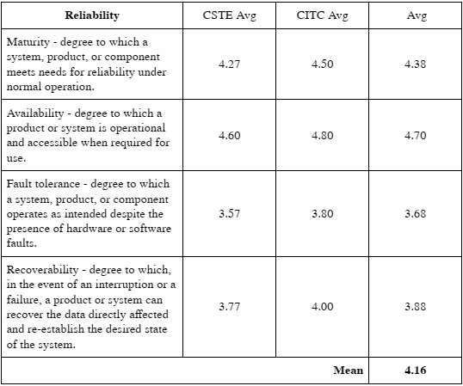

**Table 13** shows that the system demonstrates strong security with an overall mean of 4.58, excelling in non-repudiation (4.67) and authenticity (4.68) which ensures reliable tracking and validation of actions and identities. However, confidentiality (4.38) scored lower, indicating potential concerns with data access control, particularly among CITC users (4.23). Overall, the system's security is strong, but there is room for improvement in enhancing data accessibility controls to boost user confidence.

*Table 13 | Security Mean Result*

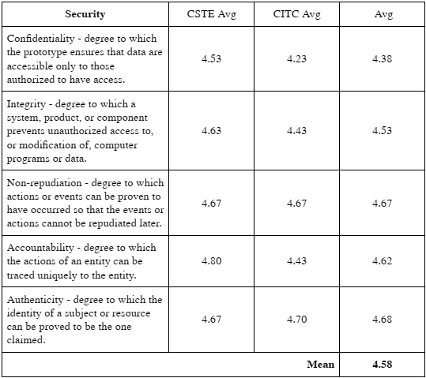

The **Table 14** below summarizes the mean scores of different ISO characteristics with Functional Suitability scoring the highest (4.68) and Performance Efficiency the lowest (4.08), resulting in an overall mean of 4.34. This means that even though it receives a high rating from the test users and the system is not flawless, it still suggests making further improvements, particularly to the areas identified earlier.

*Table 14 | Overall Mean Results*

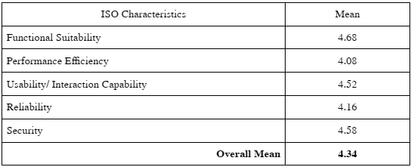

**4.5.3 Functionality Testing**

The researchers conduct functionality tests using test cases and test scenarios to evaluate how well the system performs based on its intended functionalities, how it handles various inputs and conditions, and its expected results. Then, the researchers subjected it to user testing to further evaluate the system's performance and to identify errors, bugs, defects, or any inconsistencies within its functionalities. The goal is to ensure that it works reliably well under normal usage conditions.

The **Table 15** outlines all the features available, and the results of the Functionality Testing. The functionalities mentioned above are working well as intended, providing users with a seamless experience for generating summary notes, flashcards, quizzes, and managing study sessions.

In generating summary notes, it may take several seconds or minutes, especially when processing images or documents as it scans the whole file and involves Optical Character Recognition (OCR) through the third-party API, Google Cloud Vision. This process relies heavily on a stable internet connection and OpenAI GPT-4o for its functionality. The accuracy of OCR depends on how readable and well organized the text contents of the learning materials (documents or images). There are factors that affect it such as when capturing notes and uploading images, even though it can read handwritten or digital cursive text, ensure that the text is clear, visible, and readable with a proper angle and good lighting. The upload feature for documents, images, and input text is limited to a maximum file size of 10 MB and 10,000 characters. Users are advised not to exceed these limits, as the system is designed to optimize the accuracy of summary notes. Instead, it is recommended to generate summary notes by focusing on specific topics or chapters of a lesson rather than uploading an entire book.

The quiz and flashcard generation are also highly reliant on a stable internet connection, as the system uses OpenAI GPT-4o to generate their contents. In case of an internet disruption, users are advised to refresh the system, as the request to the OpenAI may have been interrupted. Additionally, when the summary notes are edited, make sure to delete the existing flashcard or quiz and re-generate it again so that the contents will align with the updated content.

The Pomodoro Timer is enabled by default, with a standard setting of a 25-minute study session, a 5-minute short break, and a 10-minute-long break after three cycles of short breaks. Users can customize these durations in the settings to suit their preferences.

For both the sign-up and password reset processes, users must provide a valid and functional email address to receive the necessary activation or password reset email.

Furthermore, to enhance the user experience, a dark mode option has been added for better readability in low-light environments. Lastly, a gamification element, such as the badge system, has been incorporated to at least motivate users and encourage continued engagement with their studies.

*Table 15 | Functionality Test for Users (Results)*

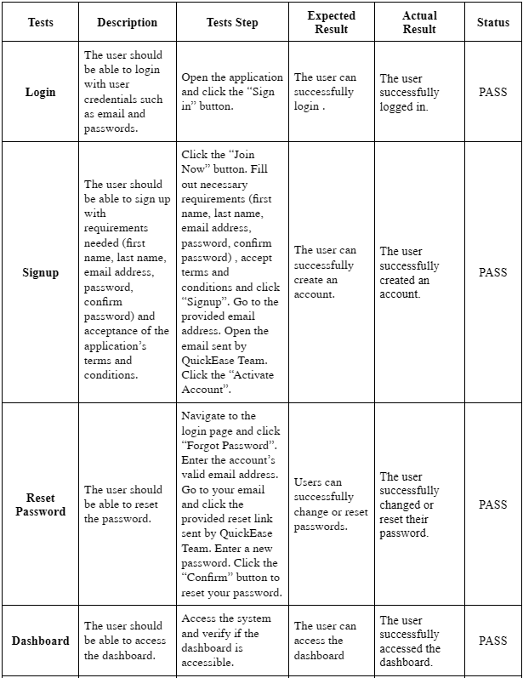

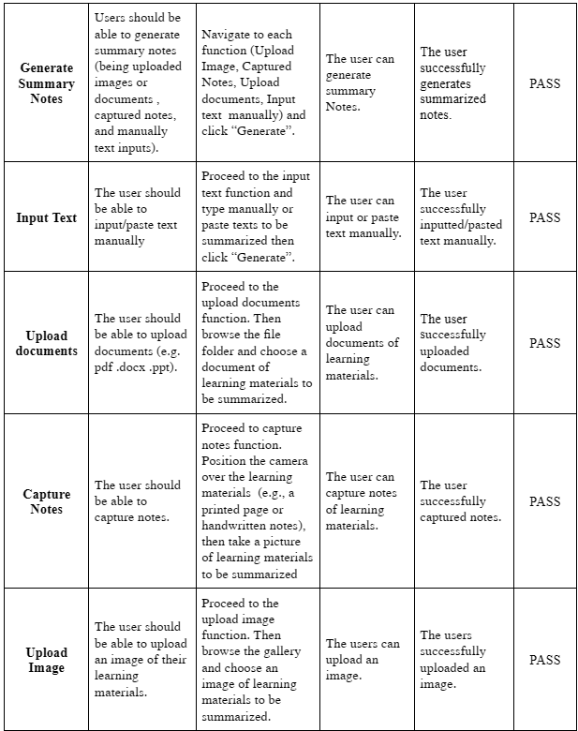

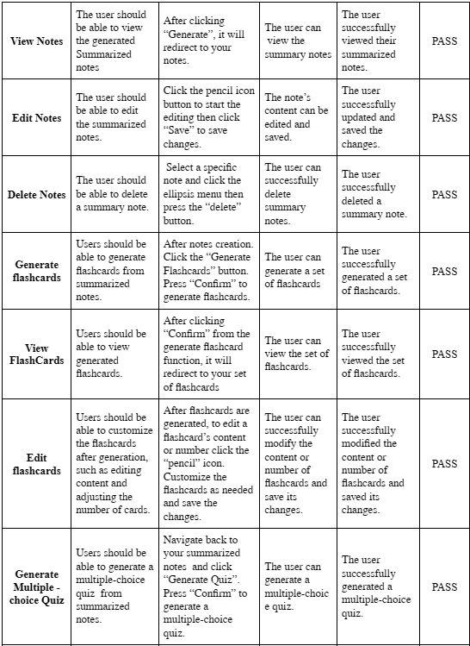

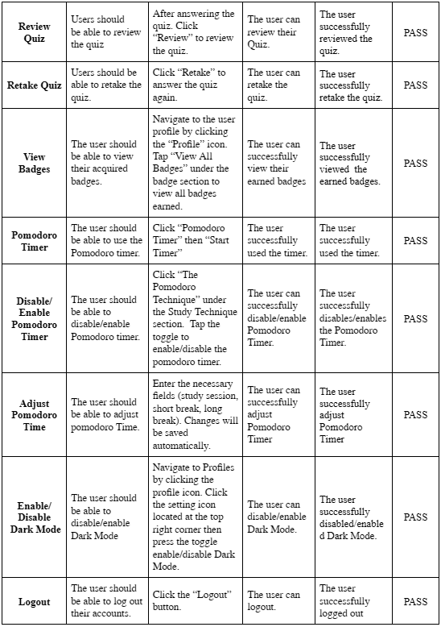

**CHAPTER V**

**CONCLUSIONS AND RECOMMENDATIONS**

This chapter presents the findings and insights gathered from the development and evaluation of the QuickEase system. It discusses the conclusions drawn from the project's results and provides actionable recommendations for further improvements and future research directions. The conclusions summarize the system's overall success in achieving its objectives, while the recommendations outline enhancements to maximize its potential impact on users.

**5.1 CONCLUSION**

The QuickEase system was developed with the primary goal of addressing the challenges students face in managing their study sessions due to overlapping academic and non-academic responsibilities. Through user testing and functionality evaluations, the project successfully met its objectives and delivered a tool that streamlines study sessions. The system leverages advanced technologies such as OpenAI GPT-4o, Google Vision, and ConvertAPI to automate the creation of summary notes, flashcards, and quizzes, effectively saving time and reducing manual effort.

The usability results, as measured by the System Usability Scale (SUS), yielded an average score of 82.29, categorizing the system as "Excellent" and well above average. However, a disparity in usability ratings between CITC (88.42) and CSTE (76.17) students highlighted differences in user experience based on prior exposure to technology. Additionally, ISO/IEC 25010 evaluations revealed high performance across Functional Suitability (4.68), Usability (4.56), and Security (4.58). However, Performance Efficiency (4.08) and Reliability (4.16) highlighted areas for improvement, such as optimizing system processes and better handling connectivity issues.

The system’s gamification elements, like badges, and the Pomodoro Timer were well-received by users, promoting motivation and time management. The testing results confirmed that the features, including the auto summarization, the auto-generation of flashcards, and the auto-generation of quizzes, worked as intended, although with limitations such as reliance on stable internet and the quality of input files. Despite these challenges, the project successfully fulfilled its goal of creating a system that improves the efficiency and engagement of study sessions, earning positive feedback from users and proving its potential to make a meaningful impact.

While the project succeeded on its objectives, limitations such as internet dependency, challenges with large or poorly formatted input files, and financial constraints limited broader access to the system. Nonetheless, QuickEase demonstrated its capacity to enhance the learning experience for students, making it a valuable tool for streamlining the study sessions of the users.

**5.2 RECOMMENDATION**

To further enhance the capabilities and accessibility of QuickEase, several improvements are recommended. First, securing a higher budget is recommended to increase the system's capacity for generating summary notes, flashcards, and quizzes by allowing for higher input and output token limits. This would enable the system to handle more complex and longer materials efficiently. A larger budget would also facilitate publishing the application on platforms such as Google Play Store, to expand the system’s accessibility to users. Developing own OCR technology is also suggested to improve the speed of processing uploaded documents and images. This would reduce reliance on third-party services like Google Vision, enabling faster generation of study materials. Additionally, expanding compatibility to iOS devices would cater to a wider audience, ensuring inclusivity for users across different mobile platforms.

Moreover, incorporating an AI-powered chatbot connected to OpenAI is recommended to provide personalized assistance to students. This feature could help users ask questions, receive explanations, and get real-time support, enhancing their study sessions further. Moreover, the Pomodoro Timer could be enriched with customizable ambient soundscapes or relaxing background music, such as café ambience or nature sounds, based on user preferences. This addition would create a more engaging and conducive environment for learning.

By implementing these recommendations, the system could significantly enhance its functionality, accessibility, and user experience, positioning itself as a robust and versatile tool for students and lifelong learners

**BIBLIOGRAPHY**

Asrani, S. (2023). How to make good flashcards. Zorbi. https://zorbi.com/making-good-flashcards/

Brooke, J. (1996). SUS: A quick and dirty usability scale. In P. W. Jordan, B. Thomas, B. A. Weerdmeester, & I. L. McClelland (Eds.), Usability Evaluation in Industry (pp. 189–194). Taylor & Francis. https://www.researchgate.net/publication/228593520_SUS_A_quick_and_dirty_usability_scale

Brooke, J. (2013). SUS: A retrospective. Scientific Figure on ResearchGate. https://www.researchgate.net/publication/285811057

Chintan A. Shah, & Prof. Neelam Phadnis. (2022). Text Summarization using Extractive and Abstractive Techniques. International Journal of Scientific Research in Computer Science, Engineering and Information Technology, 236–241. https://doi.org/10.32628/cseit228361

Gallardo-Lolandes, Y., Alcas-Zapata, N., Flores, J. E. A., & Ocaña-Fernández, Y. (2020). Time management and academic stress in lima university students. International Journal of Higher Education, 9(9). https://doi.org/10.5430/ijhe.v9n9p32

Hartman, M., Debiec, N., Kim, E., Syed, H., Adhya, J., Giardino, A., & Hill, J. (2024). Rad Path in a Flash: Creation of the First AMSER Sponsored Digital Flashcard Deck and a Review of Digital Flashcard Use among Medical Students. Academic Radiology, 31(2), 426–430. https://doi.org/10.1016/j.acra.2023.12.039

Herrera Caldas, V., Ágnes Békés, E., Maricela, C., & Illescas, C. (2020). Effective vocabulary acquisition strategies employed by Ecuadorian teachers and students: A cooperative experience using a flashcard web application. Asian Journal of English Language Studies (AJELS), 8(December).

Jhansy Archana V., Vahini, M.S.S. (2023). Auto-Summarization of text by using Natural Language Processing. International Research Journal of Modernization in Engineering Technology and Science. https://doi.org/10.56726/irjmets43798

Kusmanto, B. T., Prakisya, N. P. T., & Hatta, P. (2024). Comparative analysis of Google Vision OCR with Tesseract on newspaper text recognition. Media Computer Science, 1(2), 1–10. https://epublikasi.digitallinnovation.com/index.php/mcs/article/view/178/88

Levy, A., Agrawal, M., Satyanarayan, A., & Sontag, D. (2021, May 6). Assessing the impact of automated suggestions on decision making: Domain experts mediate model errors but take less initiative. Conference on Human Factors in Computing Systems - Proceedings. https://doi.org/10.1145/3411764.3445522

Liu, Yuyang, Song, Kevin, He, Jin, Sun, Songlin, & Liu, Rui. (2022). Design of Text Summarization System Based on Finetuned-BERT and TF-IDF. https://doi.org/10.1007/978-981-19-3387-5_159

McCombes, S. (2023). How to summarize. Scribbr. https://www.scribbr.com/working-with-sources/how-to-summarize/

Mrazek, A. J., Mrazek, M. D., Ortega, J. R., Ji, R. R., Karimi, S. S., Brown, C. S., Alexander, C. A., Khan, M., Panahi, R., Sadoff, M., Scott, A., Tyszka, J. E., & Schooler, J. W. (2021). Teenagers’ smartphone use during homework: An analysis of beliefs and behaviors around digital multitasking. Education Sciences, 11(11). https://doi.org/10.3390/educsci11110713

Nicholas, A. (2023). Writing a summary – Explanation & examples. Research Prospect. https://www.researchprospect.com/writing-a-summary/

Olmstead, L. (2024). In-app training. Whatfix. https://whatfix.com/blog/in-app-training

OpenAI. (2024). OpenAI Text Generation Capabilities and Vision Capabilities Documentation. https://platform.openai.com/docs/overview

Ramprasad, S., Ferracane, E., & Selvaraj, S. P. (2023). Generating more faithful and consistent SOAP notes using attribute-specific parameters. Proceedings of Machine Learning Research, 219, 631–649.

Sandu, B. (2024). What are monochrome colors? Design Your Way. https://www.designyourway.net/blog/what-are-monochrome-colors/

Santiago, C., & Gurat, M. (2023). Effect of Pomodoro technique on student Mendelian genetics concept mastery during synchronous remote learning. International Research Journal of Management, IT and Social Sciences, 10(4), 233–243. https://doi.org/10.21744/irjmis.v10n4.2287

Sauro, J. (2013). 10 things to know about the system usability scale (SUS). MeasuringU. https://measuringu.com/10-things-sus

Sharma, G., & Sharma, D. (2023). Automatic Text Summarization Methods: A Comprehensive Review. SN Computer Science, 4(1). https://doi.org/10.1007/s42979-022-01446-w

Shen, S., & Andaya, M. (2024). An Optimized Writing Efficiency Tool with Integrated Gamification and Work Interval Timer for Enhanced Essay Productivity and AI Advice (pp. 179–188). Academy and Industry Research Collaboration Center (AIRCC). https://doi.org/10.5121/csit.2024.140414

Shin, J., Guo, Q., & Gierl, M. J. (2019). Guidelines for writing multiple-choice items: An updated perspective. Frontiers in Psychology. https://doi.org/10.3389/fpsyg.2019.00825

Trabajo, F. M. (2020). Study Habits Profile of First Year College Students of the University of Bohol. ACADEME University of Bohol, Graduate School and Professional Studies, 9(1), 28–36. https://doi.org/10.15631/aubgsps.v9i1.81

Turhan Kariko, A. A., & Ayuningtyas, P. (2021). Examining Students’ Preferences of Quizizz and Kahoot’s as Formative Assessment and Competitiveness. Proceedings - 2021 International Seminar on Application for Technology of Information and Communication: IT Opportunities and Creativities for Digital Innovation and Communication within Global Pandemic, ISemantic 2021, 400–404. https://doi.org/10.1109/iSemantic52711.2021.9573176

**APPENDIX A: Digital Solution Showcase**



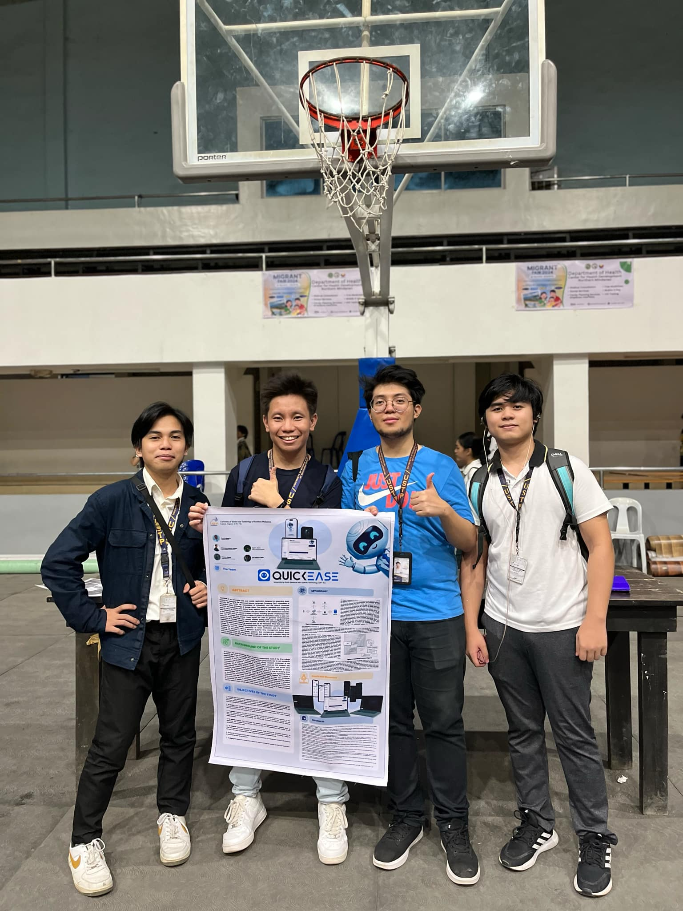

**APPENDIX B: User Manual**

**APPENDIX C: Code Snippets**

*Function Calling OpenAI Chat Completion*

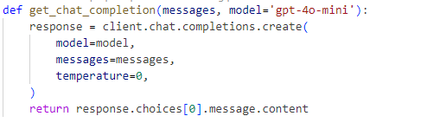

*Tokenizer for Chunk Limiting*

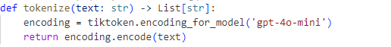

*Delimiting Chunks*

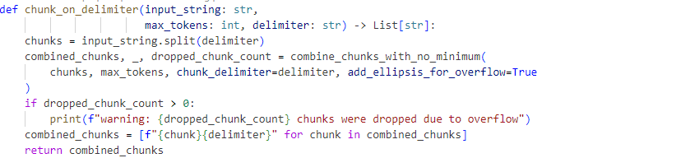

*Combining Chunks Without Exceeding Threshold*

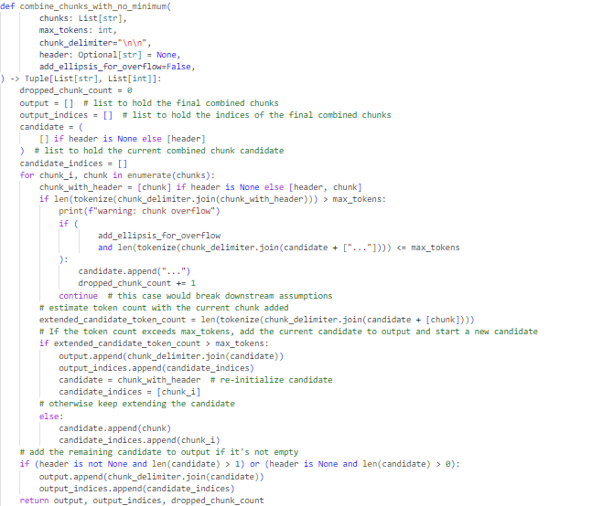

*Core Summarizer*

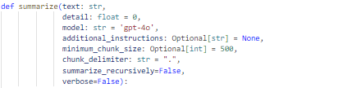

*Measurement and Initialization of Chunks to be Summarized*

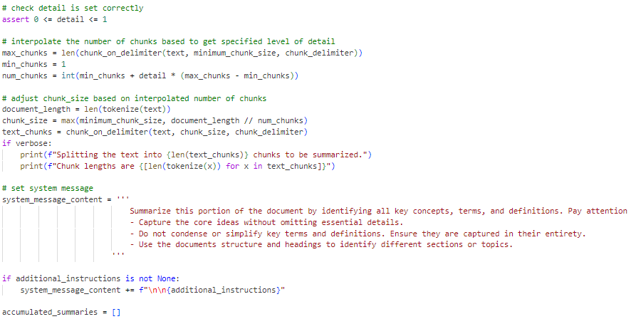

*Summarization and Final Fixes*

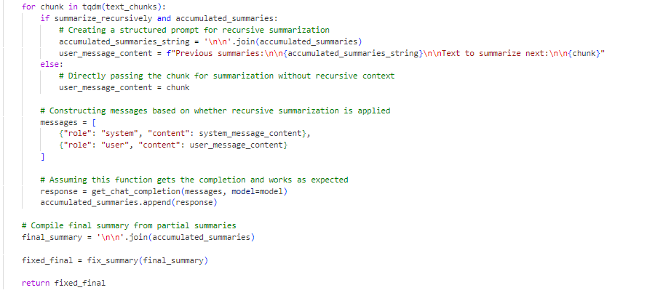

*Fixing the Accumulated Summaries*

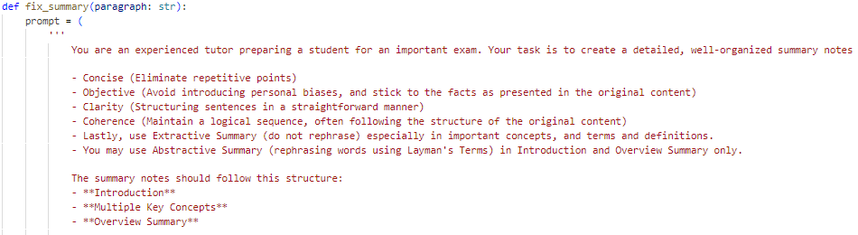

*Generate Quiz From Summary Prompt*

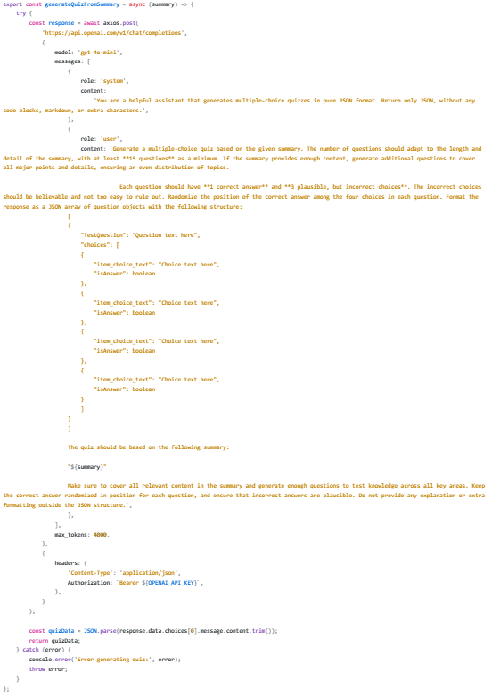

*Generated Quiz Save to Server*

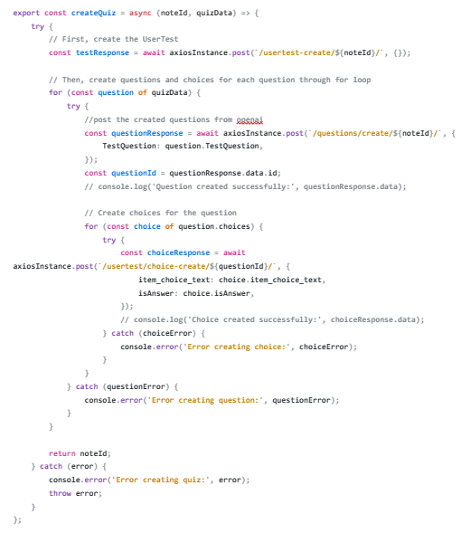

**APPENDIX D: Timeline of Tasks**

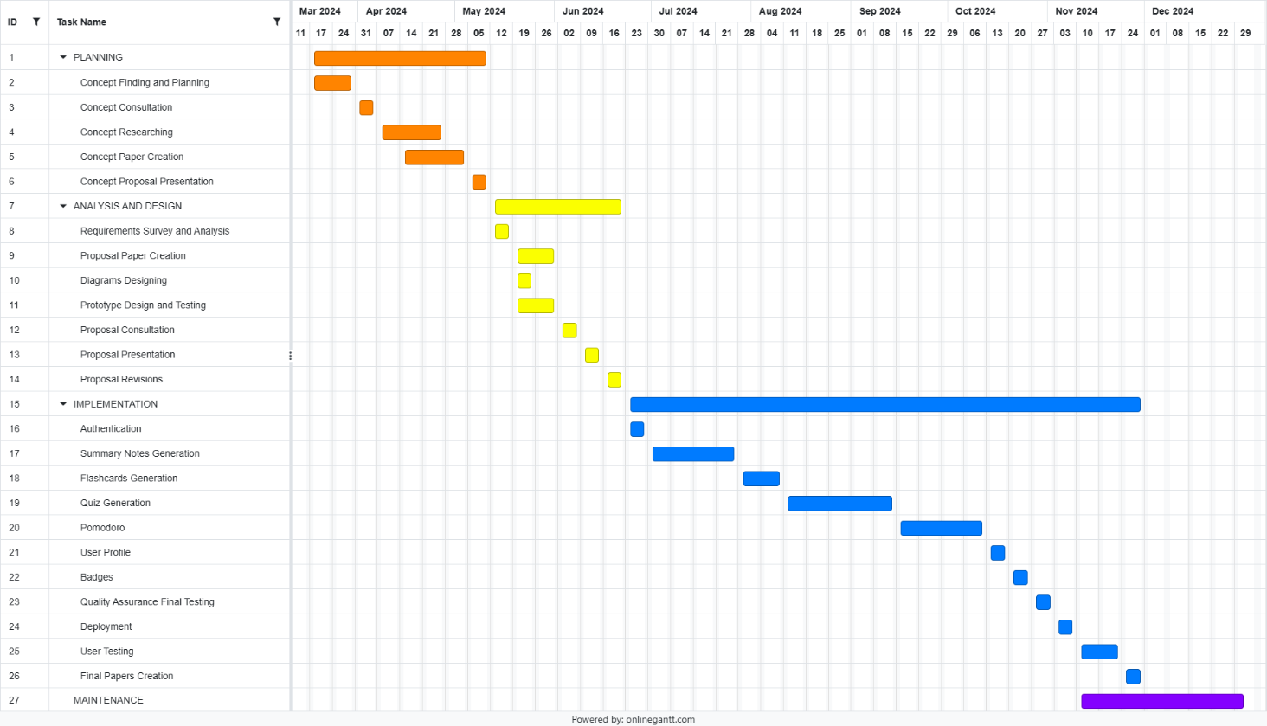

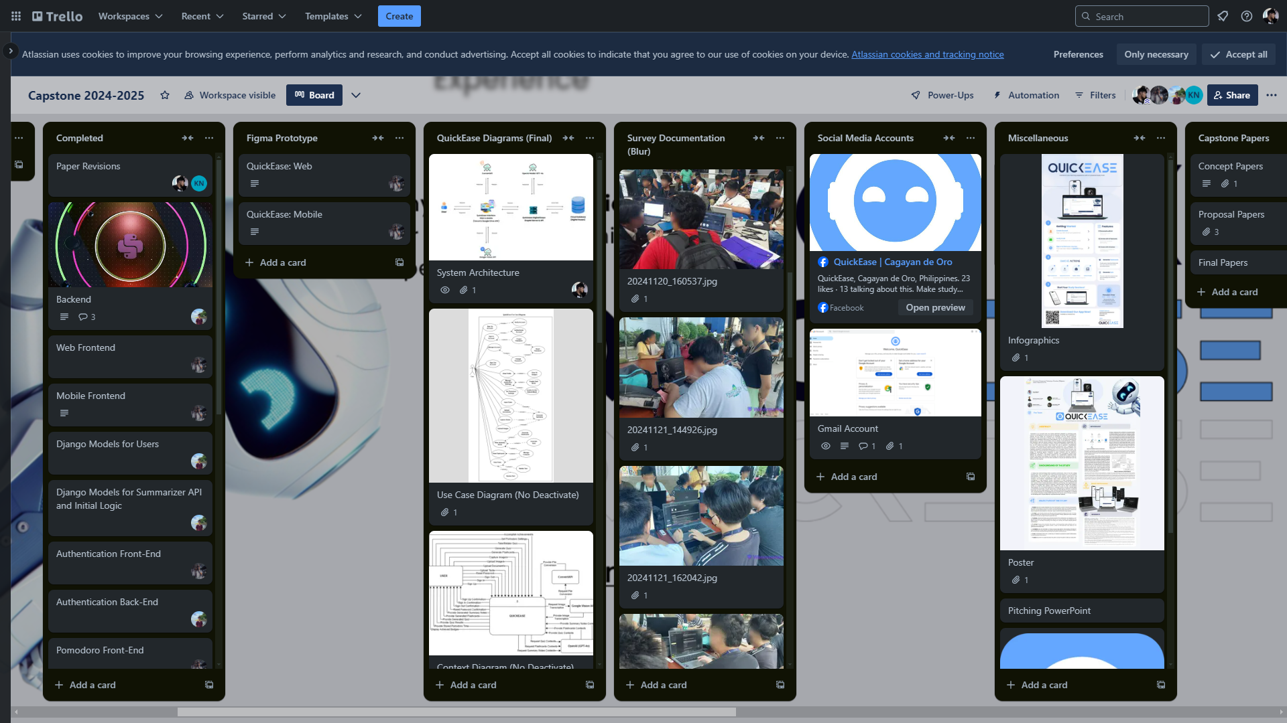

**APPENDIX E: System Evaluation Survey Questionnaires**

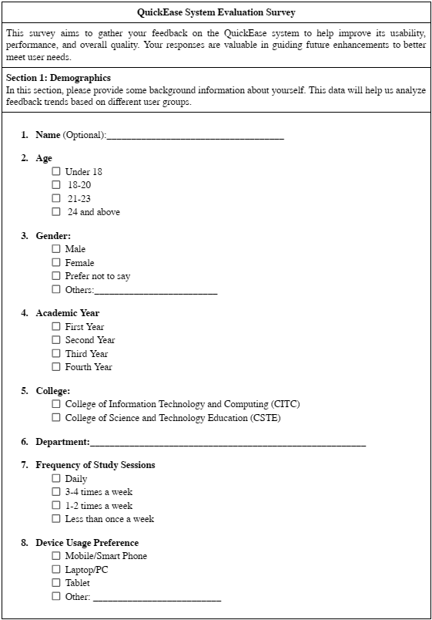

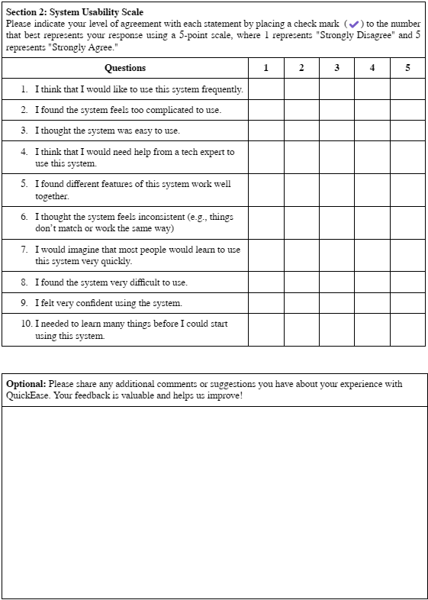

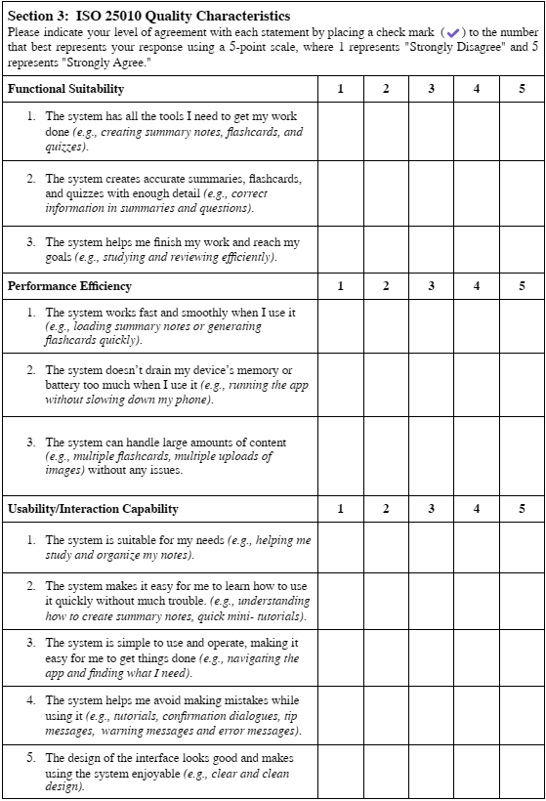

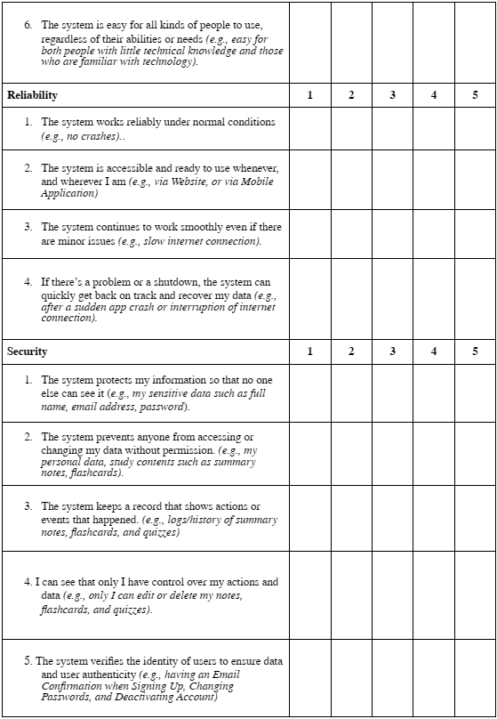

**APPENDIX F: System Evaluation Survey Documentation**

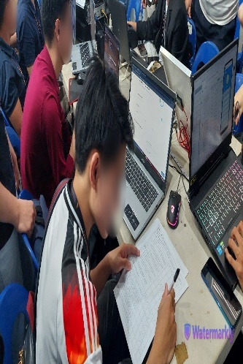 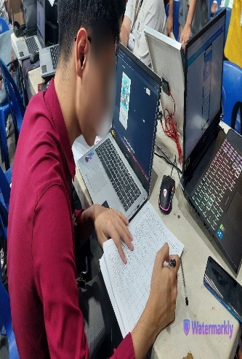 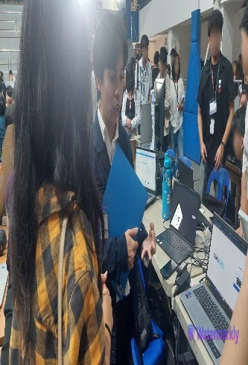 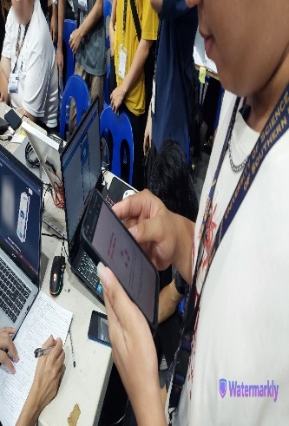

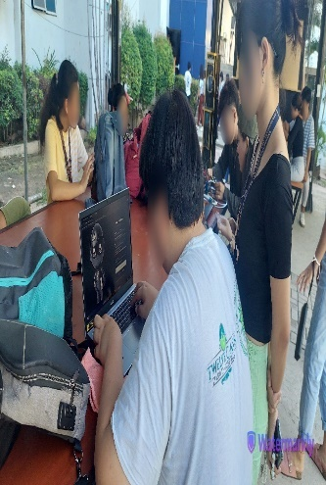 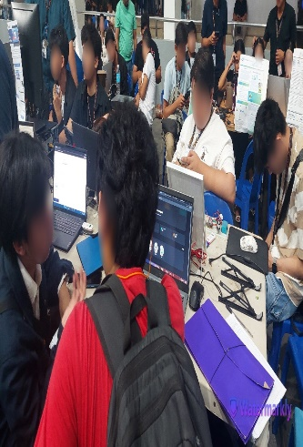 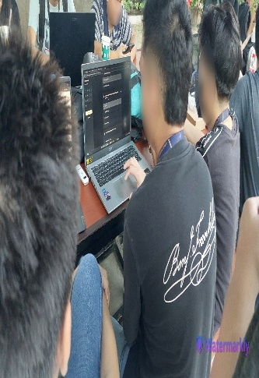 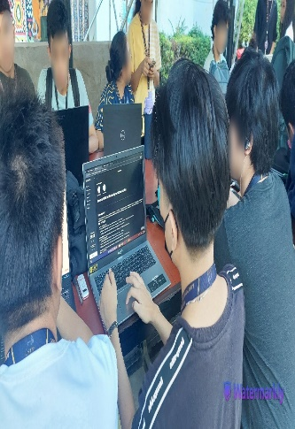

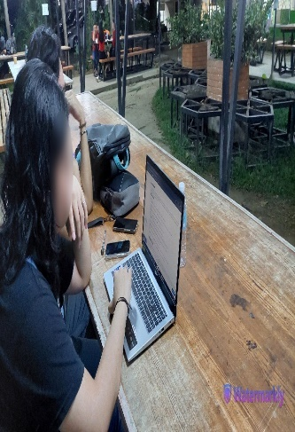 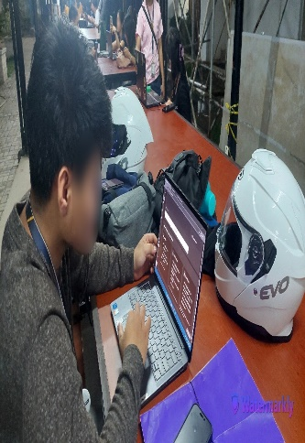 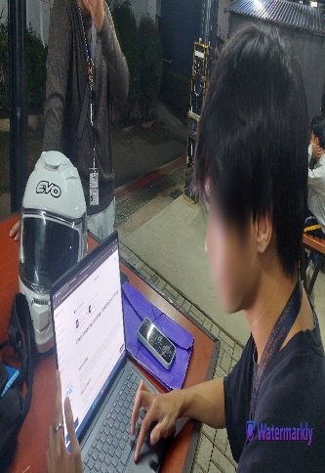 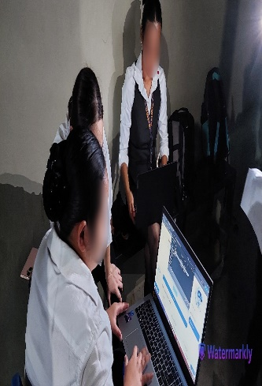

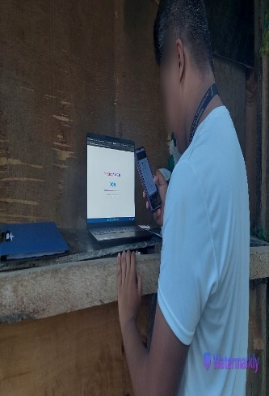 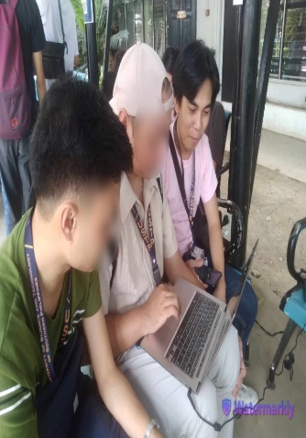 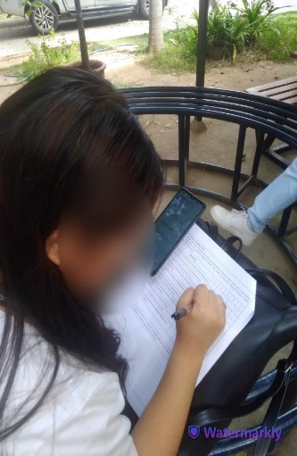 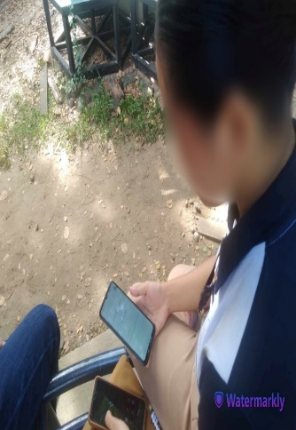

**APPENDIX G: Meeting Consultations**

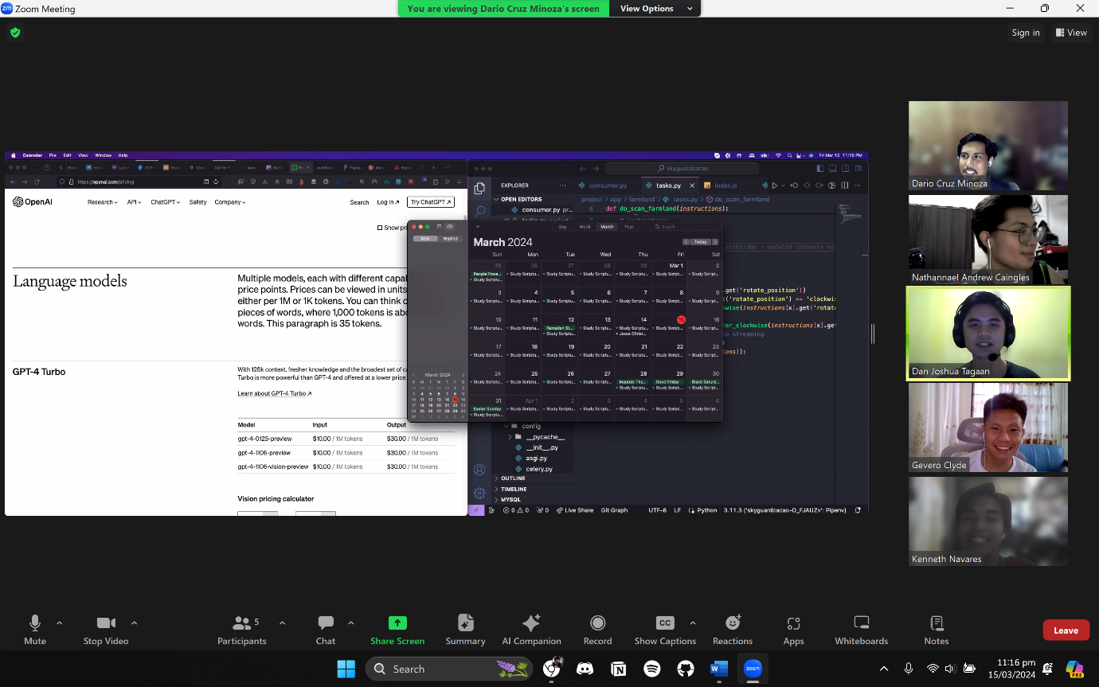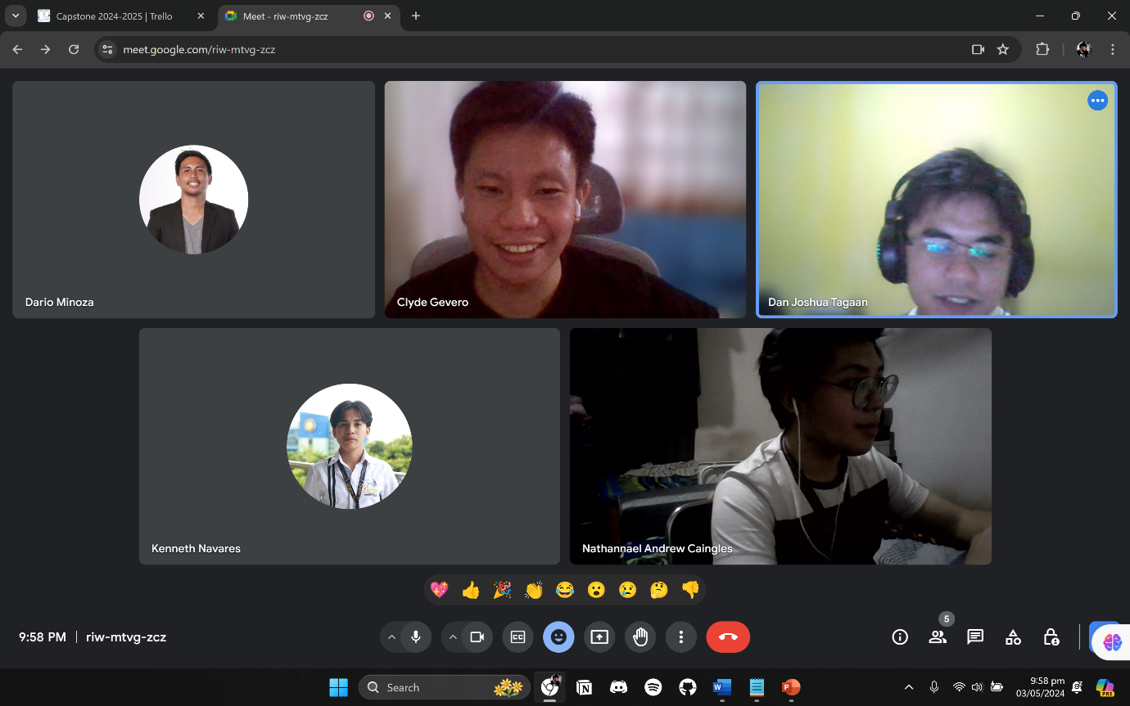

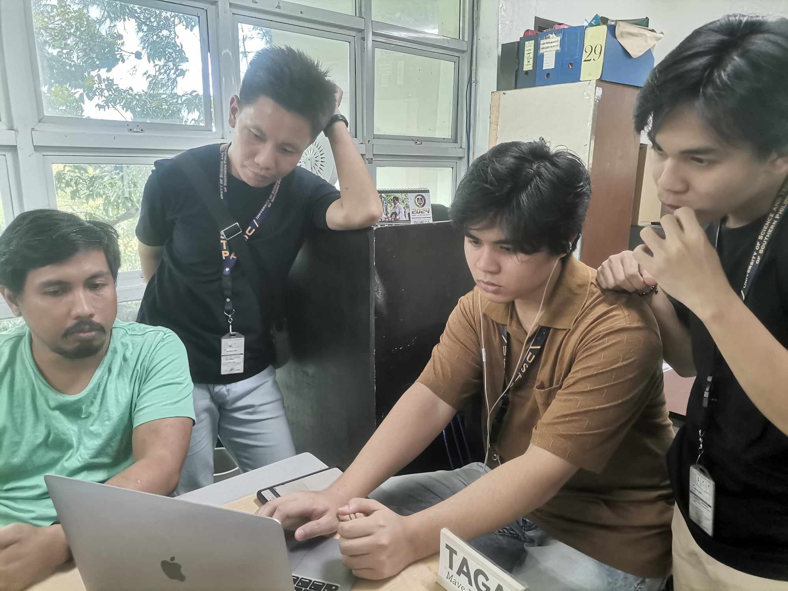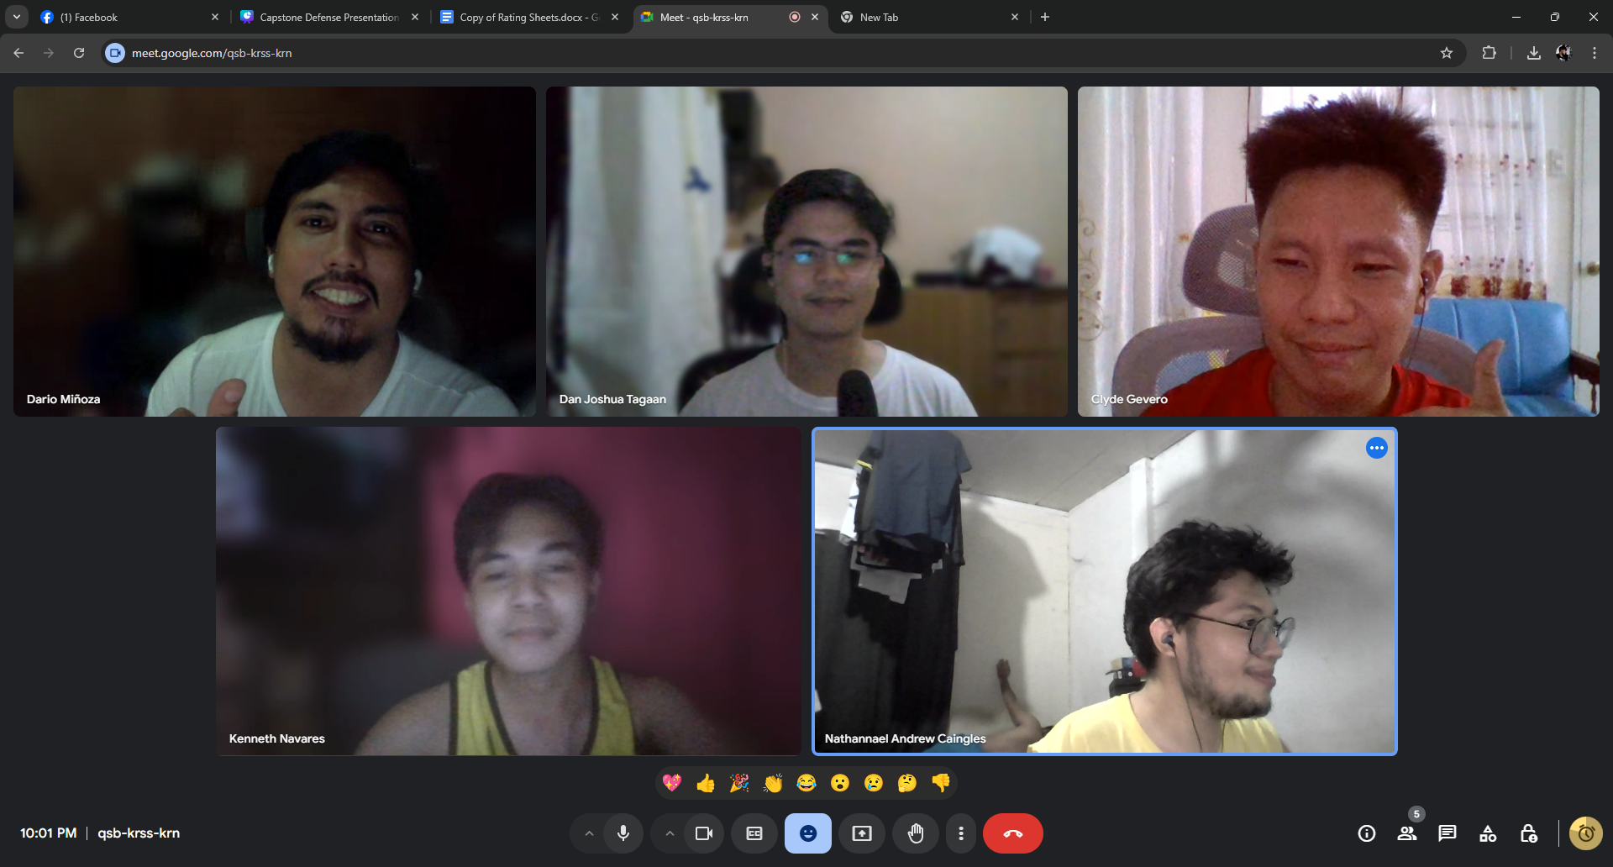

**APPENDIX H: Curriculum Vitae**

